**Spring Framework**

**Points we will study**

* What is Spring?
* Why to learn Spring?
* When to use Spring?
* DI(Dependency Injection) and IOC(Inversion Of Control) and Spring Container
* Using Depending Injection on **Primitive Type, Collection Types, Reference Types**
* Spring Container maintains the life cycle of the objects.
* How to configure the lifecycle using **XML Configuration, Spring Interfaces, Annotations**
* We will check dependency Check are injected properly and provided at runtime
* Inner Beans
* Scopes provided by Spring
* Constructor Injection
* Reading Property Files in Spring Beans
* Auto-Wiring
* Standalone Collection
* To create the Objects in Spring using Stereotype Annotations
* Spring Expression language.
* Using Interfaces and their implementation using Spring.
* Spring JDBC module
* JDBC Template
* To CRUD operations
* Spring ORM
* Hibernate Template
* Spring MVC
* DI + Spring MVC + Spring ORM = Complete Web Application
* Spring AOP(Aspect Oriented Programming) 🡪 It helps to add external services to our business methods without modifying the code.
* Spring Boot Quick Start
* Spring Security
* Spring MVC Rest Web Services.

**Important tools**

* Download JAVA(1.8)
* Download STS or Eclipse
* Download Tomcat
* Configure Tomcat in STS/Eclipse

1. Go to servers
2. Create a new server
3. Give the Tomcat Installation Address
4. Check the Ports
5. Start the server.

* Download and Install MySQL and MySQLWorkBench.
* Download Postman

**What is Spring?**

* Spring is a Depending Injection framework.
* Depending Injection 🡪 is injecting what objects require at runtime.
* Inversion of Control 🡪 It is a principle where flow of the program is inverted i.e. creation of Object OR service locator, various events is controlled automatically by framework.

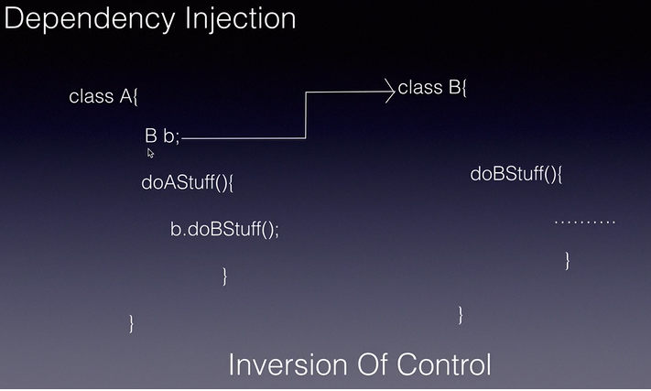

In the given example the creation of Object and inject them is handled by Framework which is known as IoC.

DI is part of Ioc.

* Spring Module consist of 20+ modules which consists of below:

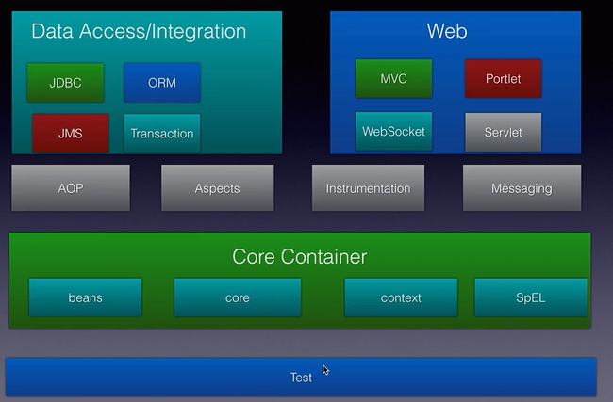

* **Core Container** is heart of the Spring Framework. It has implementation for Ioc and support for DI. It is responsible for maintaining the objects lifecycle i.e. creating of Objects, doing DI calling init() and desctroy() methods.
* **Data Access/Integration 🡪** It consist of multiple modules like JDBC, ORM, JMS and Transaction.   
  **JDBC** provides abstraction of JDBC and makes it easy to use JDBC. **ORM** integrates with Hibernate  
  **JMS** provides send OR produce OR consume messages
* **AOP(Aspect Oriented Programming) 🡪** It allows us to inject service into our objects without modifying their classes.
* **Web Module 🡪** provides basic web implementation like initiation of web container, application server.
* **Test 🡪** Provides us with basic Unit Testing.

**Spring Container 🡪** It is pre-defined program OR a component which comes with Spring which is responsible to creating the object and is responsible to holding them in memory and injecting them into other object as required. Hence it is responsible for entire lifecycle of the object.

Container needs 2 things 🡪 Beans(Java Classes) and XML config (for which we tell the container about the DI).

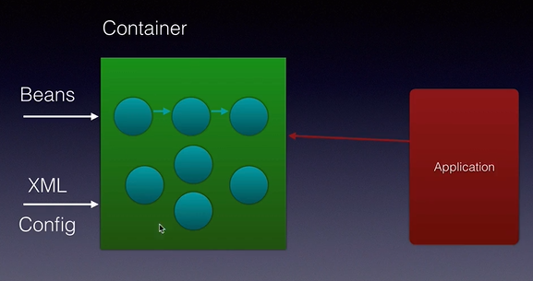

**Application Context 🡪** is a interface and implementation shown below:

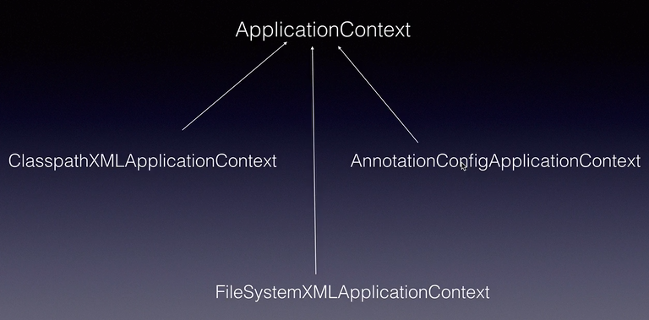

**ContextXMLApplicationContext 🡪** will search for the xml configuration on the Java Classpath.

**AnnotationConfigApplicationContext 🡪** will search for the XML configuration file on the file system

**FileSystemXMLApplicationContext 🡪** when we configure the beans using annotation

**Dependency Injection**

* It is the process of injecting what an object requires at runtime and spring framework does it for us.

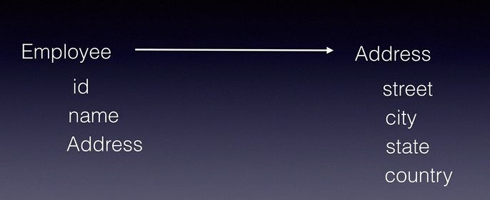In the given example, Employee needs 3 fields id, name and Address, So DI injects the value of the fields street, city, state and country in Address object and id, name, address object in employee object.

**2 Types of DI**

1. 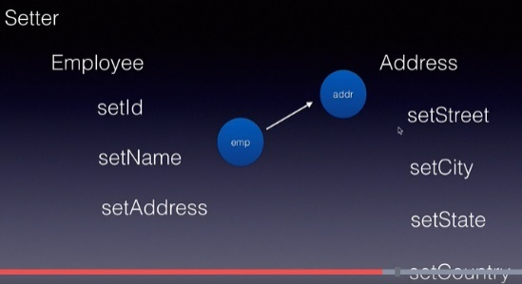Setter Injection

In this Spring will create the fields use the Setter method to set the fields and object.

1. 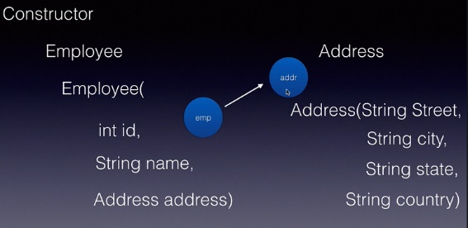Constructor Injection

In this Spring will use the constructor to inject the values. In the given example Spring will first create the Address Object and then invokes the Address Class constructor and after that it invokes the Employee constructor and inject the field and address object.

**Spring Configuration File**

* It is xml configuration file which we need to provide to Spring Container.
* The root tag of the config file is called **beans.**
* 1 **beans** tag consist of multiple bean tag, each bean tag tells Spring that a particular object needs to be created for the Bean class.
* Config file using Constructor Injection technique:

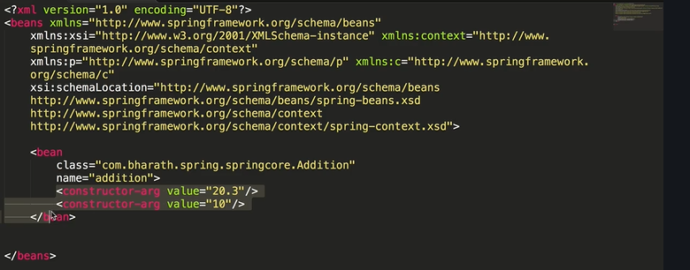

* Config file using Setter injection technique:

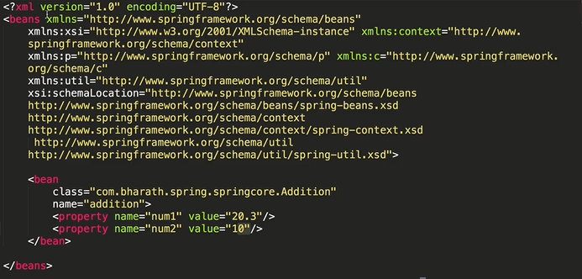

**Data Types of Dependencies**

* When the spring container creates an object and does the dependency injection for that particular object it does it based on the types of data, that object depends on. Based on it, there are three types of data or dependencies.
* 3 types of Dependency Injection:

1. Primitive Types Dependencies 🡪 It includes all the primitive java types including String.
2. Collection Types Dependencies 🡪 It includes List, Set, Map, Properties
3. Reference Type OR Object Dependencies 🡪 It includes the object of other classes.

**Injecting Primitive Types**

* The primitive type dependencies can be injected using constructor injection or setter injection and using the value tag.

**Setter Injection**

1. Create a Maven Project
2. Select Archetype as maven-archetype-quickstart.
3. Give the group id 🡪 this is the package under which Spring keep our project.
4. Select Artifact as SpringCore(ProjectName).
5. **After creating the project put the following inside the pom.xml which will automatically fetch all the dependencies.**

<properties>

<springframework.version>4.3.6.RELEASE</springframework.version> // **This property is sued below**

</properties>

<dependencies>

<dependency>

<groupId>org.springframework</groupId>

<artifactId>spring-core</artifactId>

<version>${springframework.version}</version> //**This property defined above is used**

</dependency>

<dependency>

<groupId>org.springframework</groupId>

<artifactId>spring-context</artifactId>

<version>${springframework.version}</version>

</dependency>

</dependencies>

<build>

<pluginManagement>

<plugins>

<plugin>

<groupId>org.apache.maven.plugins</groupId>

<artifactId>maven-compiler-plugin</artifactId>

<version>3.2</version>

<configuration>

<source>1.8</source>

<target>1.8</target>

</configuration>

</plugin>

</plugins>

</pluginManagement>

</build>

1. **Steps for DI.**
2. **Primitve Type Injections**
3. Create the POJO classes (i.e. Spring Bean) 🡪 Create Employee Bean as shown below:

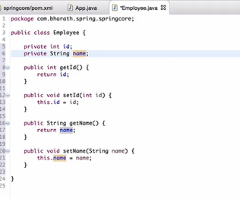

1. Create the Configuration file 🡪 In the config file each **bean** tag represents a separate bean and name can be any but it will be used further and class we need to give the fully classified name of the Bean(POJO). Under it we have Property tag in which name will be exact name of field in the class and value will be value of the field (Assigning the value to the field is called Dependency Injection)

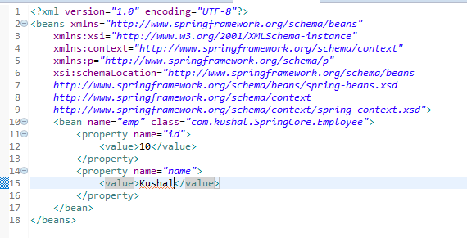

1. Create the test to test the Bean 🡪 Inside the Test class we need to create the Spring Container.

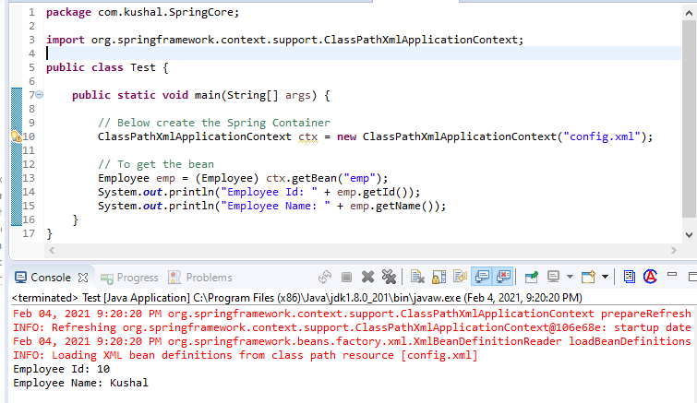

1. Inside config.xml we have defined the **value as element** instead of value we can define **value as attribute** as shown below:

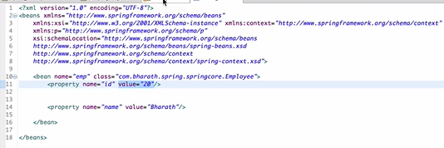

1. Inside config.xml now we will use **p:schema to define the values.**

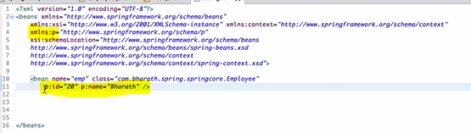

1. **Injecting Collections 🡪** Spring supports below Collection Types:

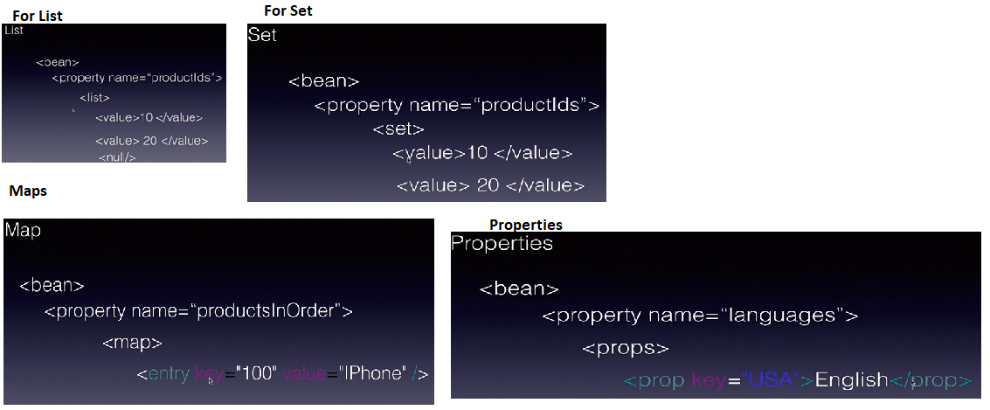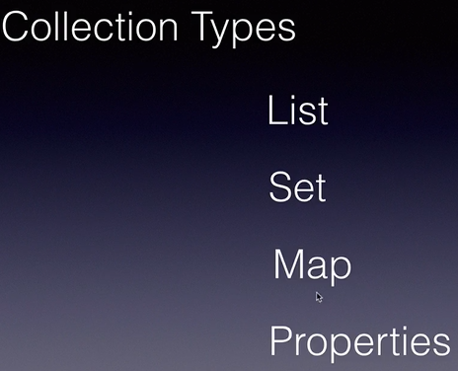

**List Implementation**

1. Create POJO Hospital i.e. Spring Bean(name and List of Departments)

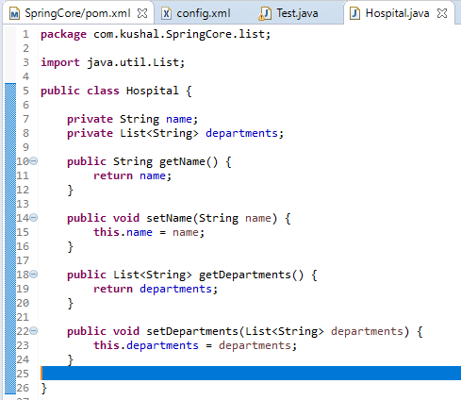

1. Create Configuration file(listConfig.xml):

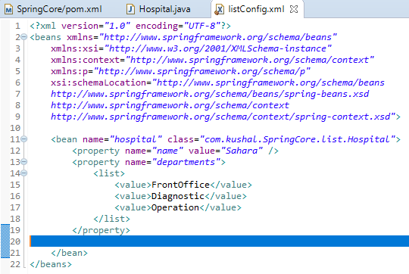

1. Create the Test Class

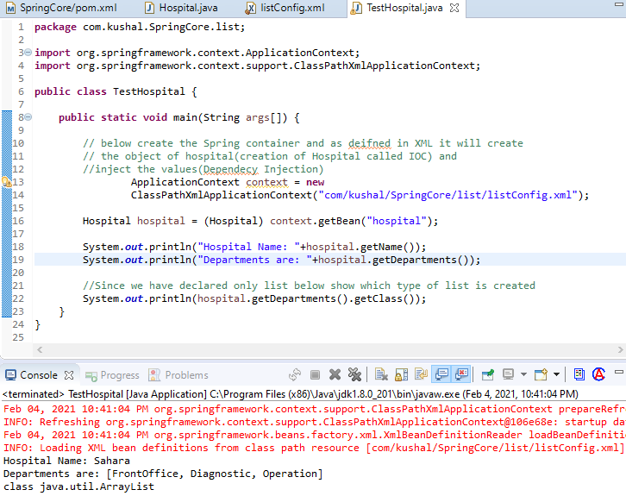

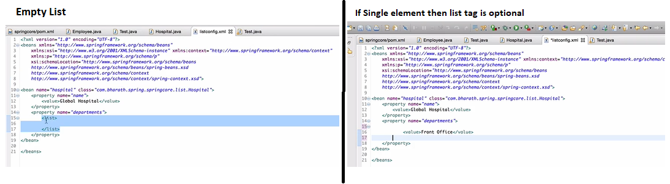2 Points On List:

**Set Implementation**

**Example:**

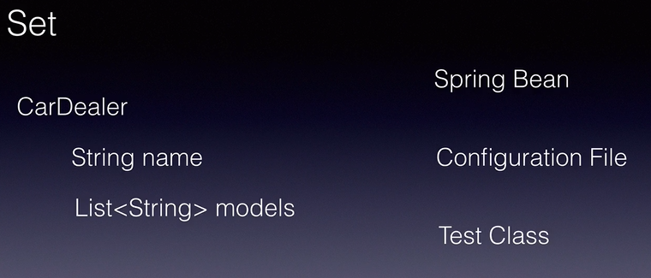

1. **Create POJO class of CarDealer**

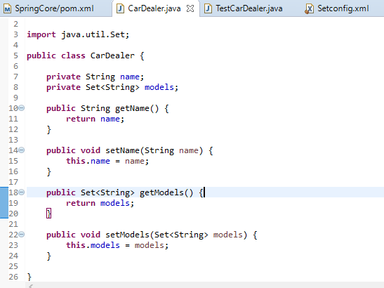

1. **Create Configuration file**

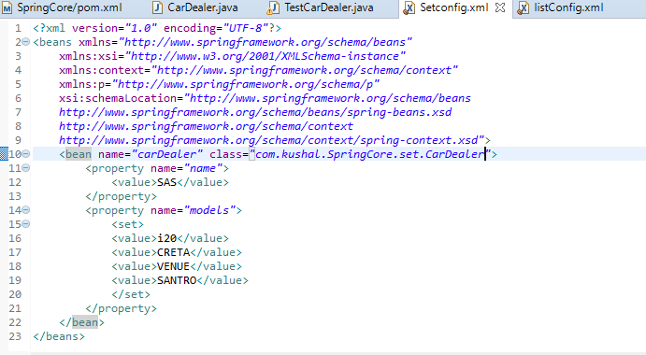

1. **Test Class**

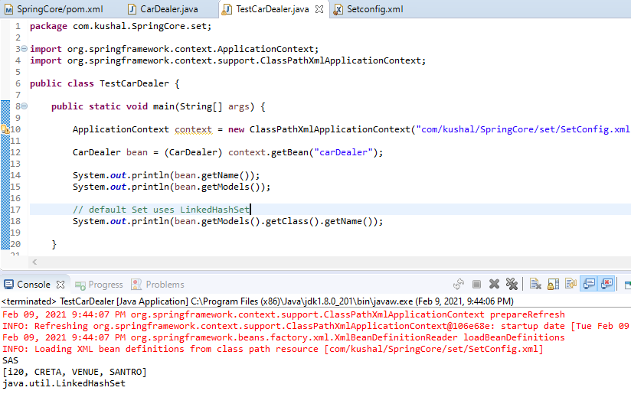

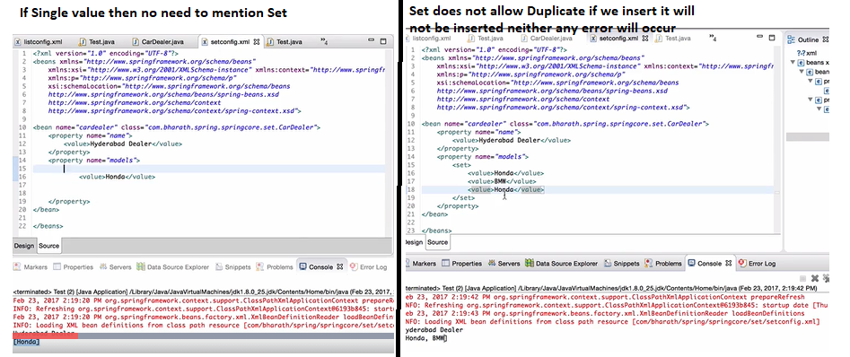**Imp Points**

**Map Implementation**

**Example:**

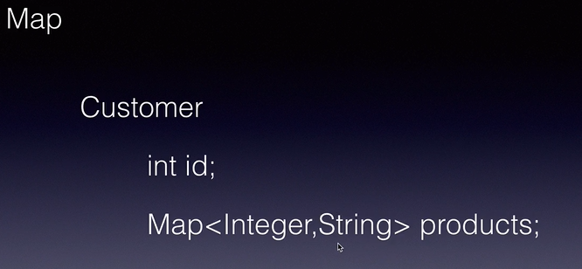

1. **Create a Pojo class of Customer** i.e. Spring Bean

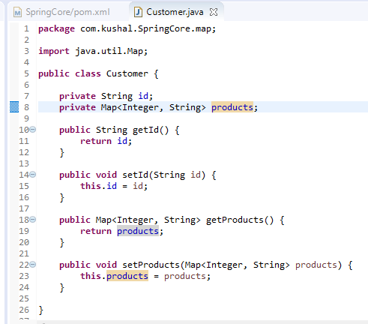

1. **Create Configuration File 🡪 MapConfig.xml**

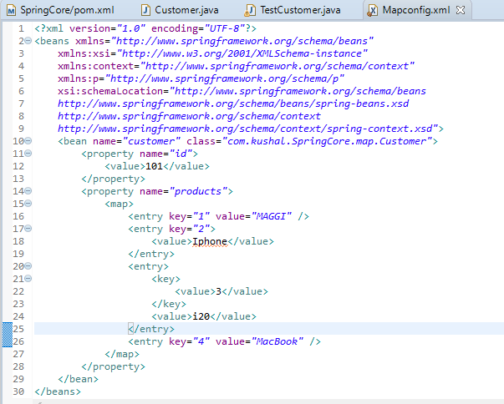

1. **Test Class**

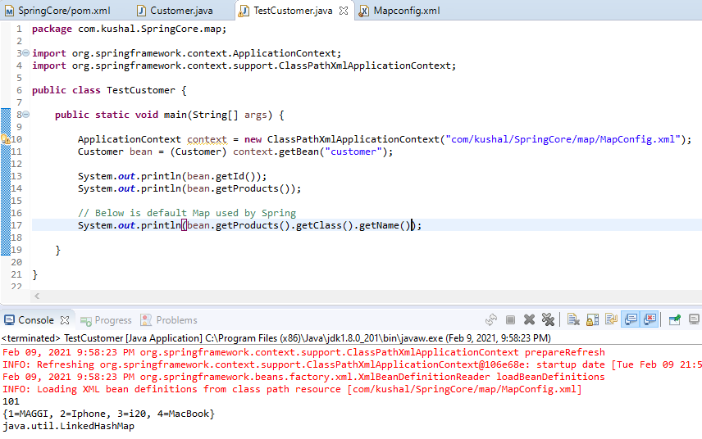

**Properties Implementation**

**Example:**

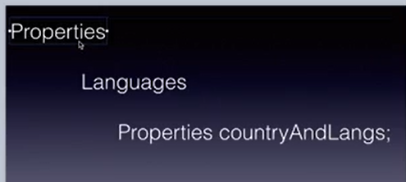

1. **Create a Pojo Languages** i.e. Spring Bean

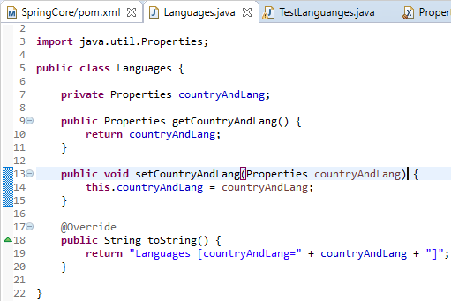

1. **Create the Spring Configuration file**

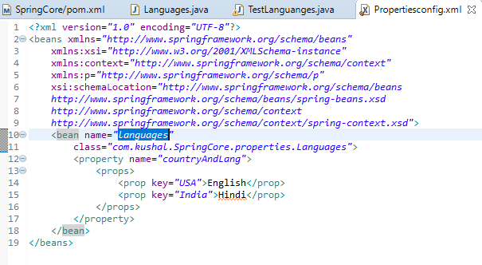

1. **Create the Test Class**

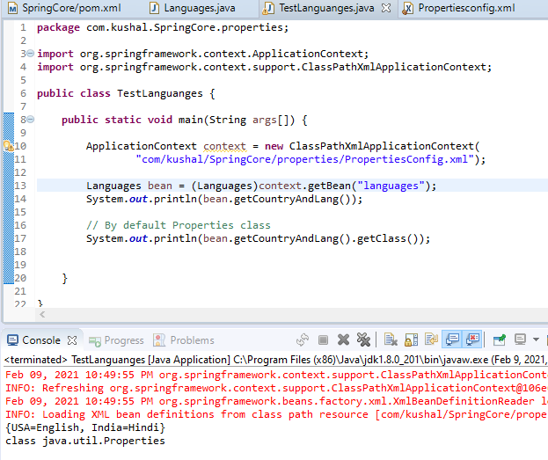

**Reference Type Implementation**

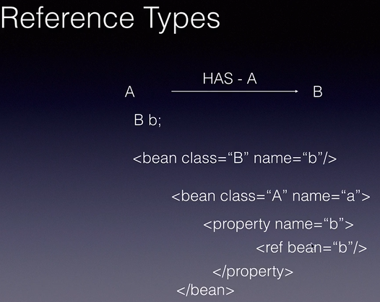

**UseCase**

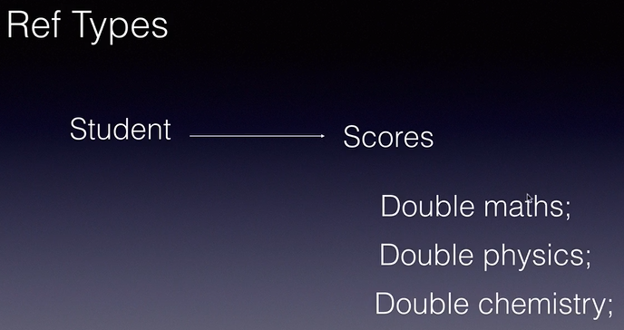

1. **Create Pojo Classes 🡪 Student and Score** i.e. Spring Bean

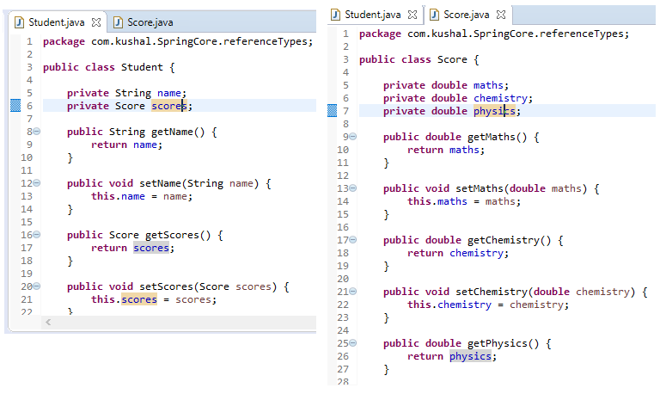

1. **Create Spring Configuration file**

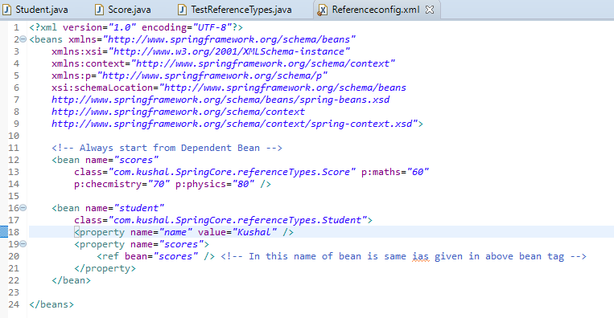

1. **Create the Test Class**

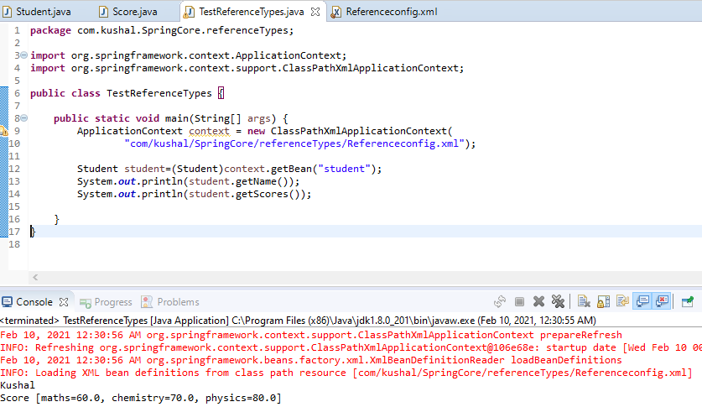

1. **Using Ref as an attribute and p schema in Configuration file**

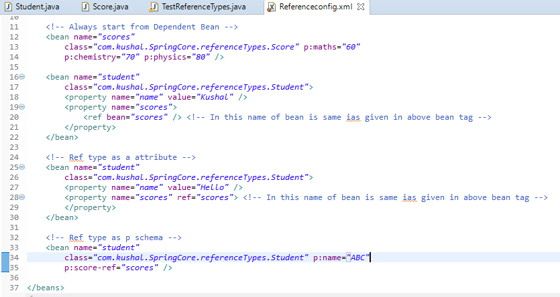

**Life Cycle Methods**

* Spring Creates 2 methods for lifecycle of the bean🡪 public void init() and public void destroy().
* All the initialization code such as loading configuration loading file system goes in init() method
* All the clean up code such as closing of connection goes in destroy() method.

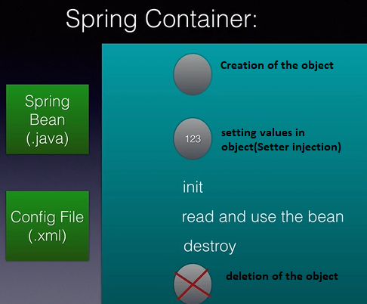

* We can configure the lifecycle method using 3 ways:
  1. XML Configuration
  2. Spring Interfaces
  3. Annotations

1. **Life Cycle method using XML configuration.**

**Example**

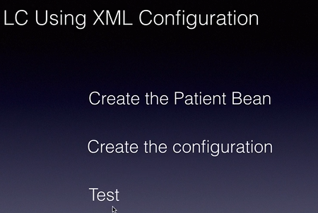

1. Create the POJO i.e. Spring Bean class called as Patient, The name of the init() and destroy() method is not mandatory to as it can be any name but same needs to be configured inside config file.

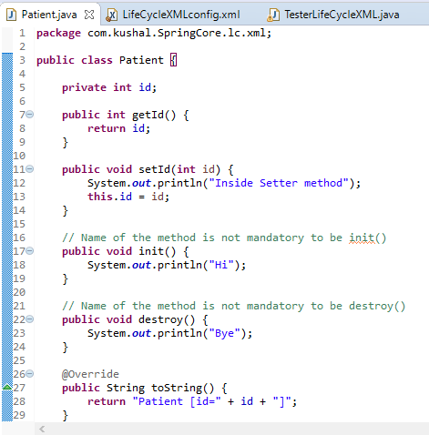

1. Create configuration file 🡪 Inside this we can see to initialize the init() and destroy() method.

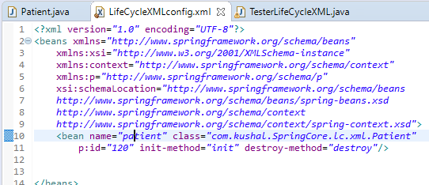

1. Tester class. 🡪 By default Destroy method will not be invoked and we need to tell Spring Container to invoke the Destroy method before destroying the Object which is done by **registerShutdownHook**() method present in **AbstractApplicationContext.**

In below execution it is clear that Spring container before initiating the init() method it does Setter injection.

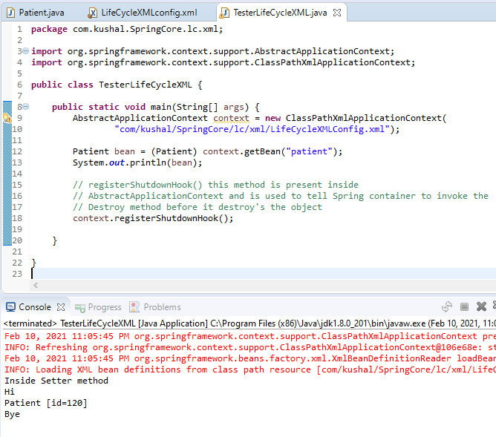

1. **LifeCycle method using Spring Interfaces**
2. Create the POJO class i.e. Spring Bean Patient which implements 2 interfaces InitializingBean which contains afterPropertiesSet() method which is used as init() method and DisposableBean which contains destroy() method.

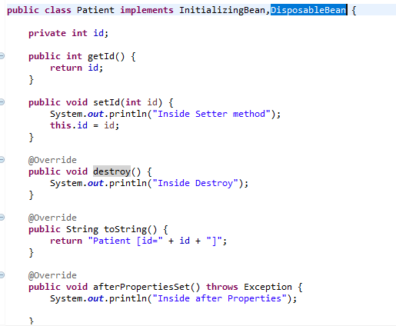

1. **Create the configuration file**

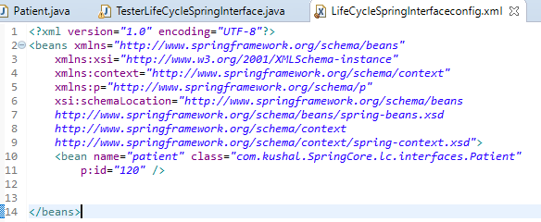

1. Tester class:

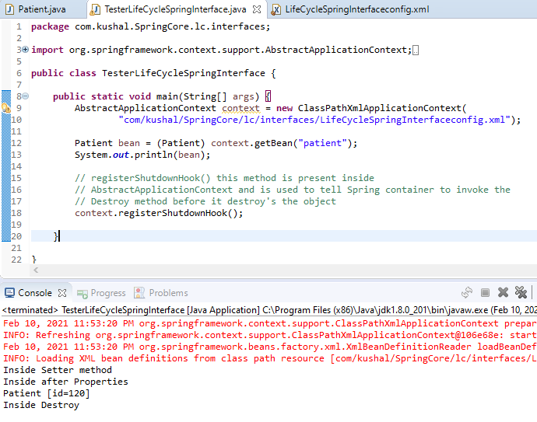

1. **Lifecycle method using Annotations**

* **By default in Spring all the Annotation Support is disables, to enable use below tag:**

<context:annotation-config />

1. Create the Pojo class i.e. Spring Bean Patient and mark the init() and destroy() method with annotation as **@PostConstruct @PreDestroy** to make the method behave as init() and destroy() method.

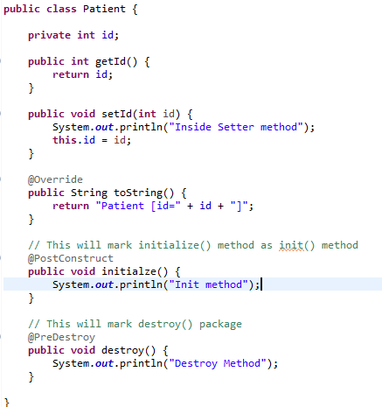

1. Create the configuration file.--> By default annotation are not enabled in we need to define the below tag in config file to enable the Annotations

<context:annotation-config />

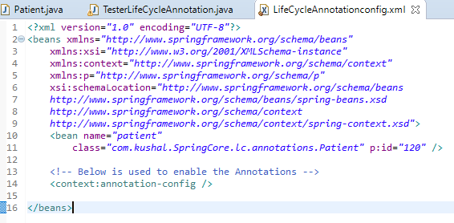

1. Test Class:

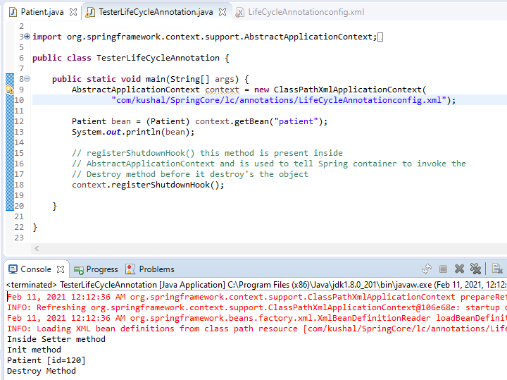

**Summary:**

* **The names of the lifecycle method need not be the same but the signature should be exactly the same it should be public void and no parameters.**

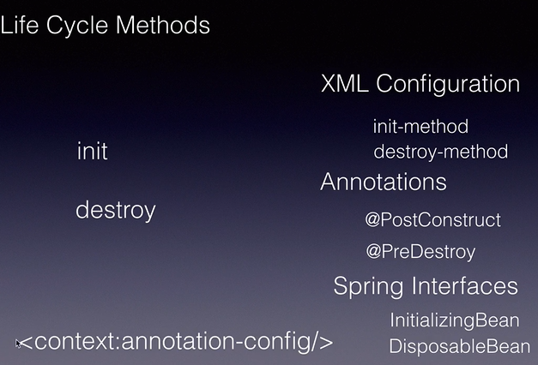

**Dependency Check Inner Beans and Scopes**

* In this we will study how to mandate the field in the request.

Use Case:

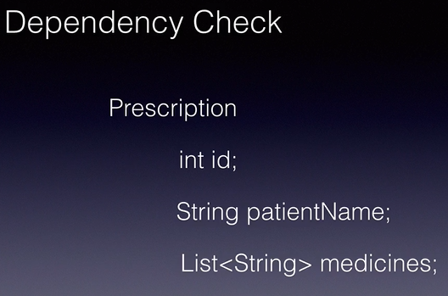

1. Create the Pojo class i.e. Spring Bean and mark the field as Mandatory. We cannot use the annotations on the field, we need to mark them in setter method. **@Required** annotation is used mark the field as mandatory.

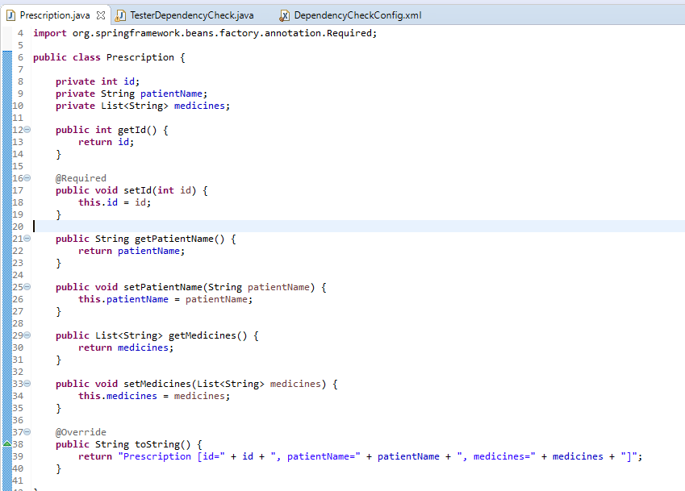

1. Configure the spring config file

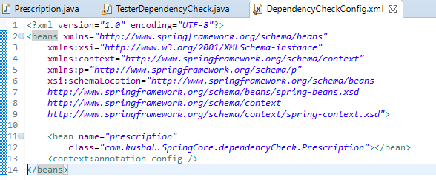

1. Create the Test class and run:

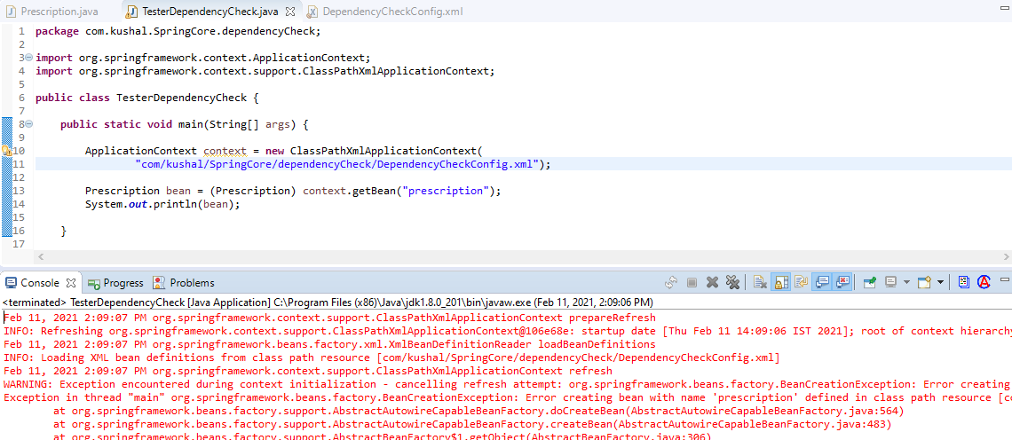

In this when we run the Test class we can see the error as “**id**” field is mandatory

ARNING: Exception encountered during context initialization - cancelling refresh attempt: org.springframework.beans.factory.BeanCreationException: Error creating bean with name 'prescription' defined in class path resource **[com/kushal/SpringCore/dependencyCheck/DependencyCheckConfig.xml]: Initialization of bean failed; nested exception is org.springframework.beans.factory.BeanInitializationException: Property 'id' is required for bean 'prescription'**

As in above we can see we can see we are getting **BeanInitializationException.**

1. Now modify the configuration file as below and define the id field

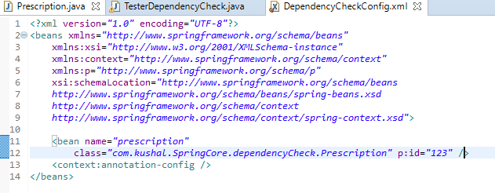

After this when we would run the Test class, we would not get any error.

**Create and Configure Inner Bean**

UseCase:

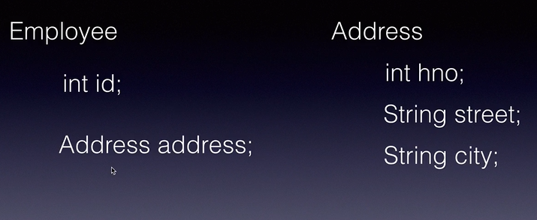

In this we will use **has a relationship.**

1. 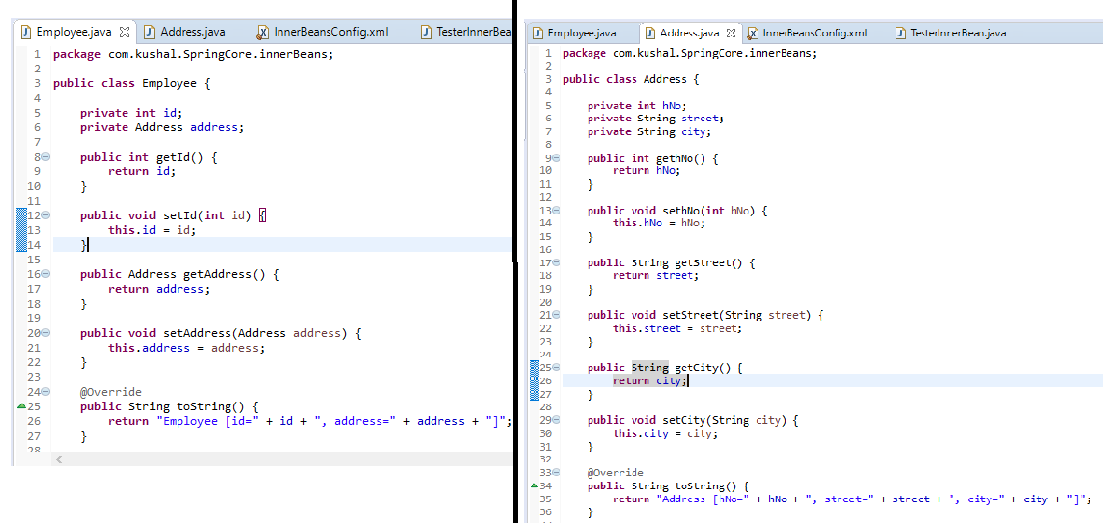Create the Pojo i.e. Spring Bean of Employee and Address.
2. Create the configuration file:

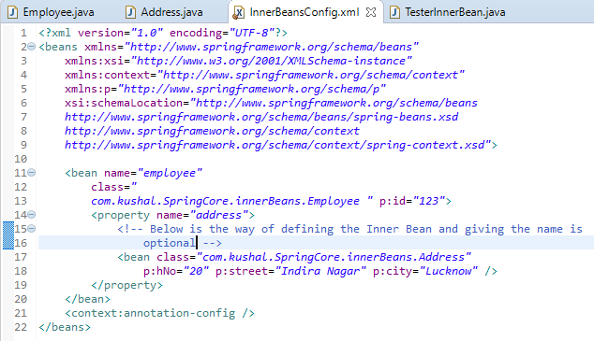

1. Create the test class:

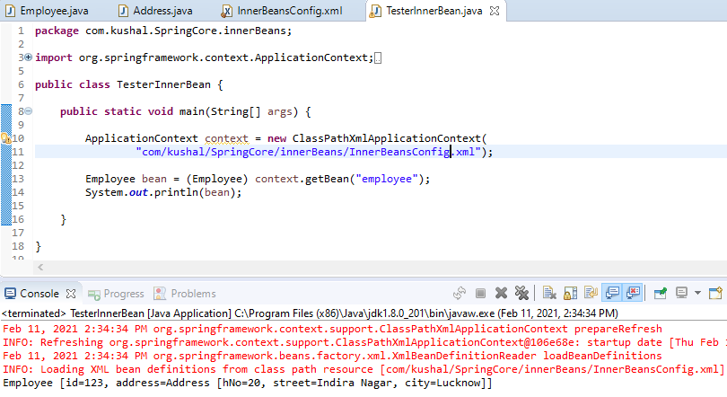

* Now we know the 4 ways to inject:

1. As Element
2. As Attribute
3. As p schema
4. Inner Beans 🡪 This can be used only in reference type and only when inner beans “**has a**” relationship.

**Spring Beans Scopes**

Scope of the availability of Object in the container, it is the no. of object created in the container of a bean type.

There are 5 possible values:

1. Singleton 🡪 is a default value, when we configure the bean in the Spring configuration and don’t provide any scope then it is singleton and Spring container will create only 1 object of it even through it is accessed multiple times.

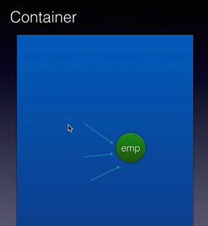

1. prototype 🡪 When we mark the bean as prototype then Spring container will create the object every time it is read and used in our application.

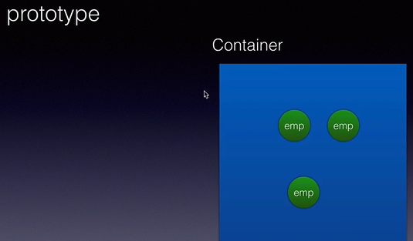

1. request 🡪 It is only applicable only for Spring MVC web application, when request comes from user browser, and Spring container will create the object per request.

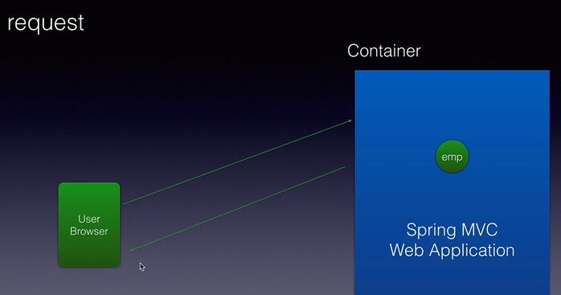

1. session 🡪 It is only applicable for Spring MVC web application, a session everything when user login’s and logout OR everything when happens from the time user access the website and leaves the website. When we mark the bean as a session scope then Spring container will create the one object per session.

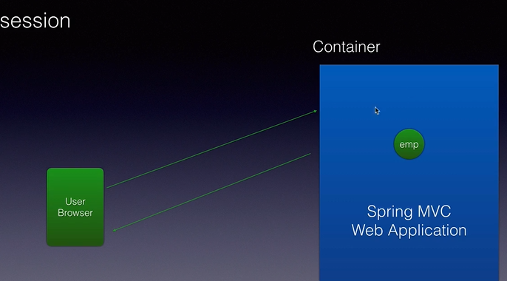

1. globalsession 🡪 It creates 1 object per global session which is used in Spring MVC Portlets.

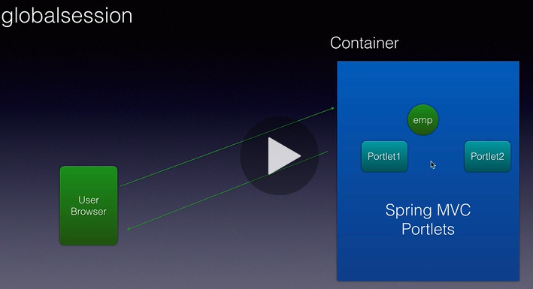

**Implementation of Scopes**

We will enhance the Inner bean project implementation.

1. **Singleton Scope Implementation**
2. In config file, since no bean scope is given, so both the bean employee and address is **singleton.**



1. In test class: 🡪 We have get the bean twice but object is same as both the object reference have same hashcode.

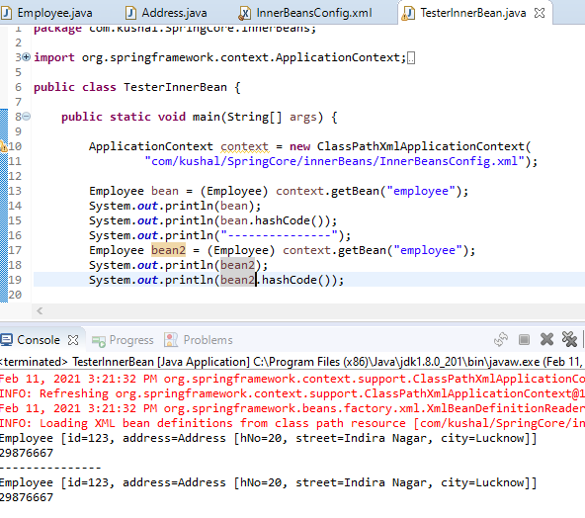

1. **Prototype Scope**
2. In this modify the configuration and add **the attribute name scope in the bean tag and give the value as “prototype”**

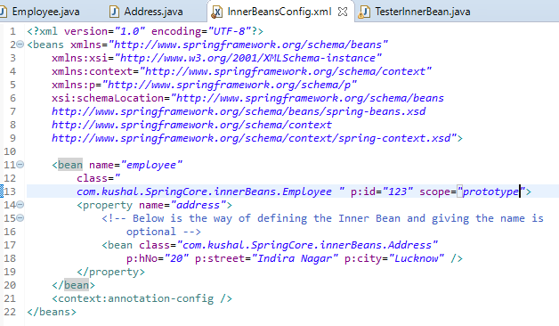

1. Now when run the Test class we can see both the object reference are showing difference hashcode.

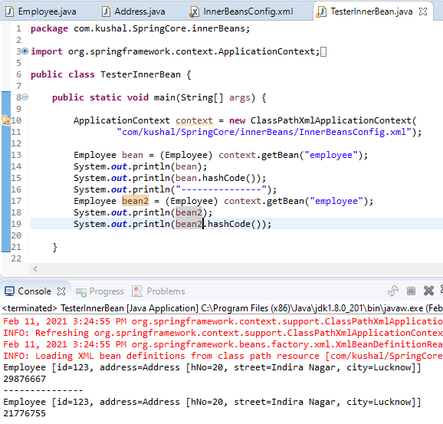

**Summary of Dependency Check, Inner Beans, Scope**

* In dependency check, we can use to make the attribute OR reference OR field as mandatory to run the application, by default when initialization Spring gives default value to object but when we put @Required annotation and does not provide any value we will get **BeanInitializationException.**
* In Inner Beans, we have learnt how to configure bean inside bean.
* In Scopes we have learnt 5 different scopes🡪 singleton, prototype, request, session, globalsession. By default Spring container uses Singleton scope.

**Constructor Injection**

* Spring supports creating the object using parameterized constructors

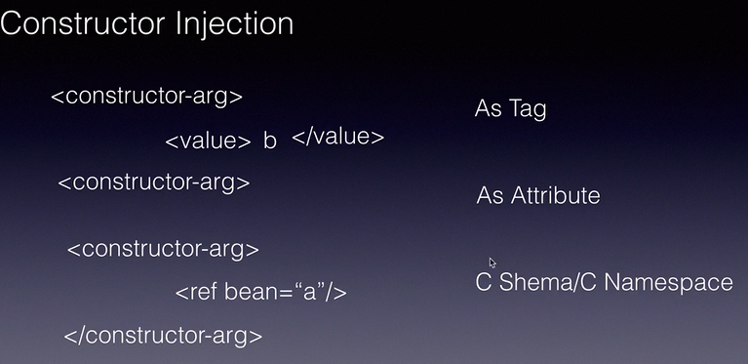

**Constructor Injection As tag**

1. 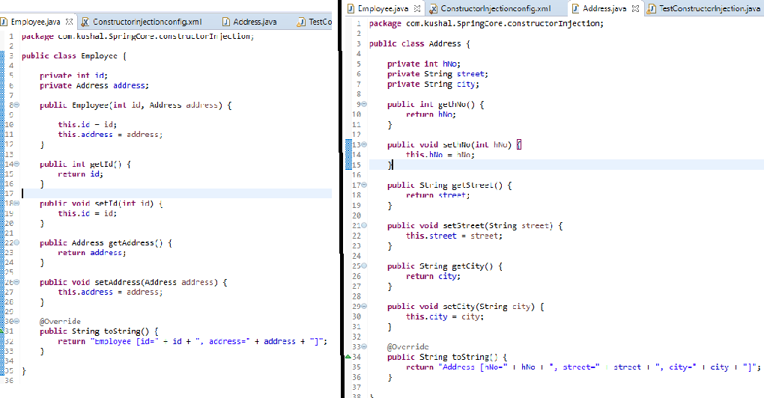**Create Pojo class i.e. Spring Bean of Address and Employee Class 🡪** In Employee class we created the parameterized constructor and used this Constructor injection.
2. **Create Spring xml file 🡪** For constructor injection, we used constructor tag for Employee Bean as shown below:

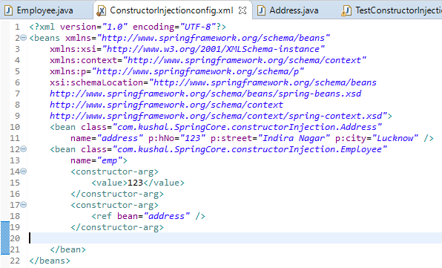

1. **Tester class**

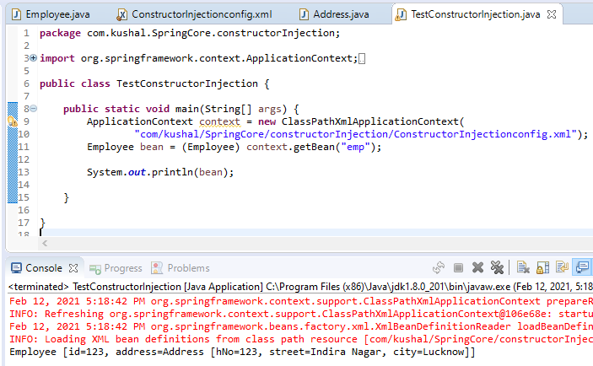

1. **Constructor Injection using element, attributes and c schema in Spring Configuration file**

* **Below is for attributes:**

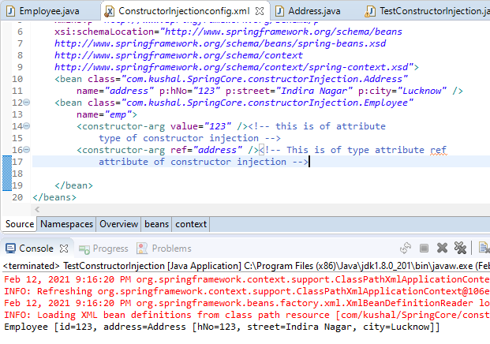

* **Below is for c schema 🡪** In this we need to import the new schema in namespace as well.

**“xmlns:c=**[**http://www.springframework.org/schema/c**](http://www.springframework.org/schema/c)**” this name space need to added.**

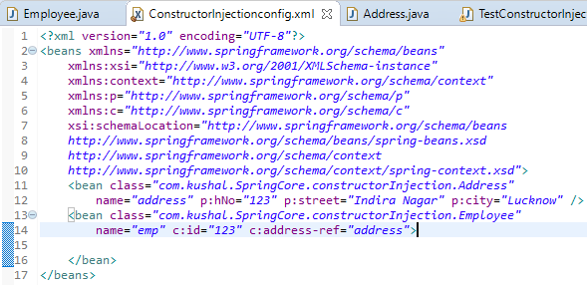

* **Ambiguity problem: 🡪** To see ambiguity problem we will create the Addition class Pojo and create the parameterized constructor overloaded, with arg as int, double and String, and then we would running this Spring will invoke Constructor. *By default the value provided in the Config file Spring considers it as a String if Spring finds the Constructor with Spring arg then it would be considered else Spring will invoke constructor in the order in which they are defined.*
* 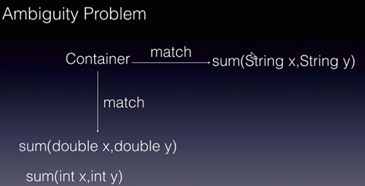

1. **Create Addition Pjo class i.e. Spring Bean**

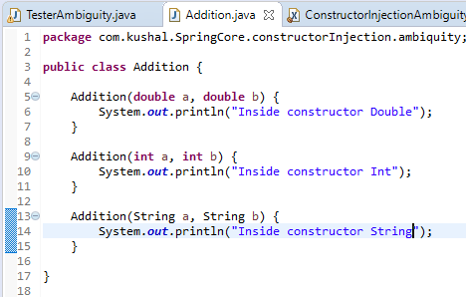

1. **Configuration file:**

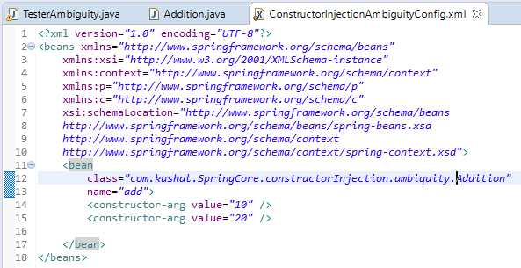

1. **Tester class**

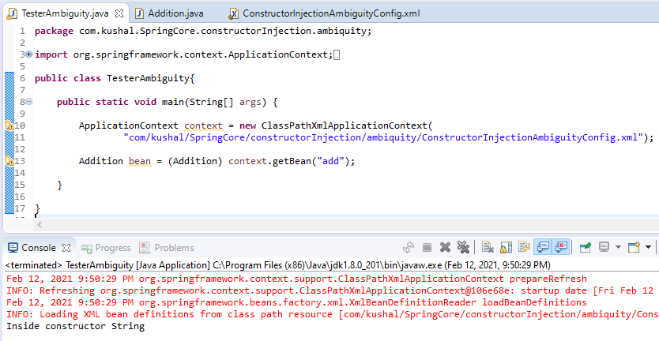

* **This Ambiguity can be solved using 3 different attributes 🡪 type, index, name.**

1. Use of “**type”** attribute 🡪 By this Spring container will invoke the Int type arg constructor

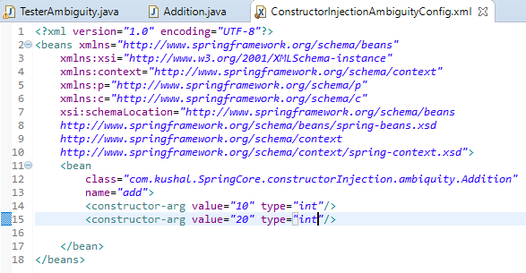

1. Now if we have only 1 constructor in Addition class having arg int and double

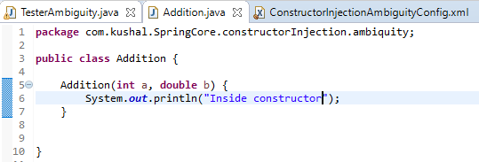

**Config.XMl as below:**

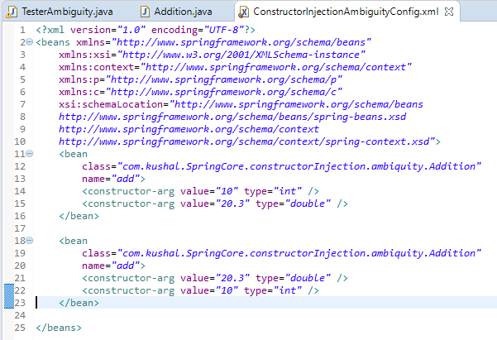

**Tester class o/p:**

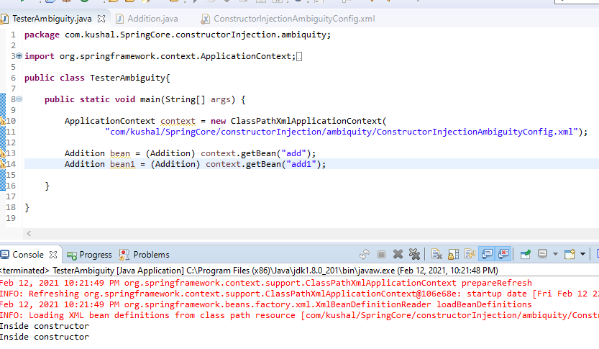

**Hence, in this we can see the sequence does not matter and Spring gives output in both the cases.**

* In case we need to make sure of sequence then we need “**type”** attribute as shown below:

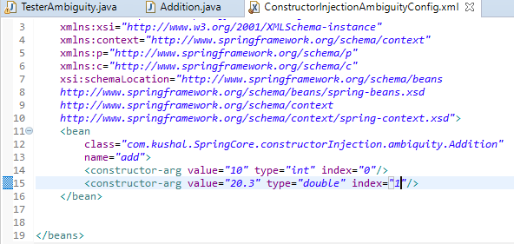

In this we consider the index 0 as first argument and 1 as the second argument as given in the Addition class.

If we change the index as below:

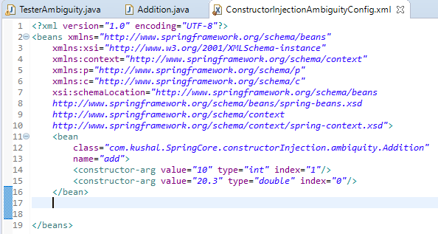

Then when running the tester class we will be getting the exception as:

Feb 13, 2021 12:39:54 AM org.springframework.context.support.ClassPathXmlApplicationContext refresh

Exception in thread "main" org.springframework.beans.factory.**UnsatisfiedDependencyException: Error creating bean with name 'add' defined in class path resource [com/kushal/SpringCore/constructorInjection/ambiquity/ConstructorInjectionAmbiguityConfig.xml]: Unsatisfied dependency expressed through constructor parameter 0: Ambiguous argument values for parameter of type [int] - did you specify the correct bean references as arguments?**

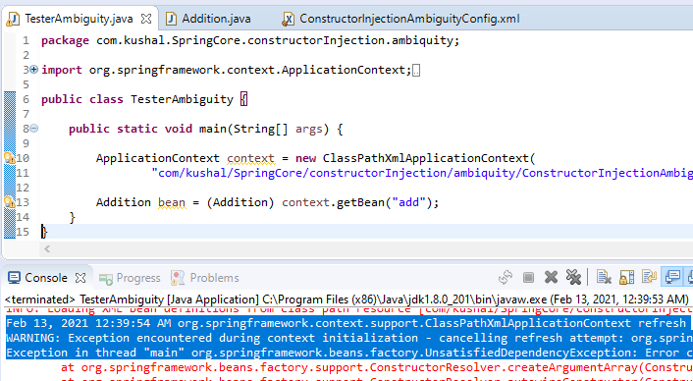

**Notes:**

* Spring container use parameterized constructor for DI instead of setter injection when we have configured to use constructor injection.
* We use tag **<constructor-arg>** inside bean.
* The number of tag inside bean will be number of argument we used in constructor.

**Bean Externalization OR Reading Properties**

* In Real time application, we have some properties which cannot be hardcoded and use properties file instead. If we need to change the value then these properties need changed only in Properties file.
* In Spring, we have Property place holder configuration to link these Properties file with our XML. In 3 steps:

1. Create the Properties file
2. Link the property file in XML configuration
3. User properties in XML and inject

**UseCase:**

1. Create the file called “database.properties”

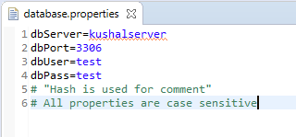

1. Create a Pojo Class i.e. Spring Bean called MyDao.

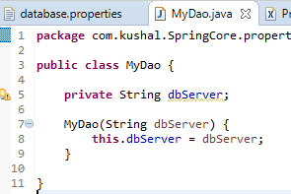

1. Create Config file 🡪 In config file, we will use the context property placeholder to get the Properties file and used the constructor injection. To get the value from the properties file **${propertyName}.**

* **Note We can also use @Value(“{property}”)** annotation for injecting value on fields during Bean initialization

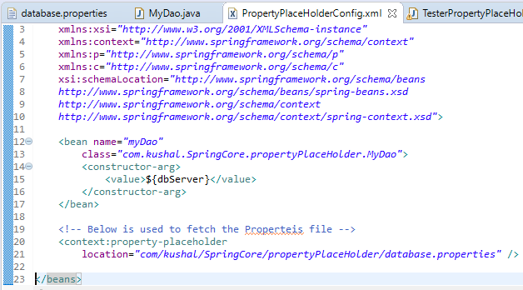

1. Tester class

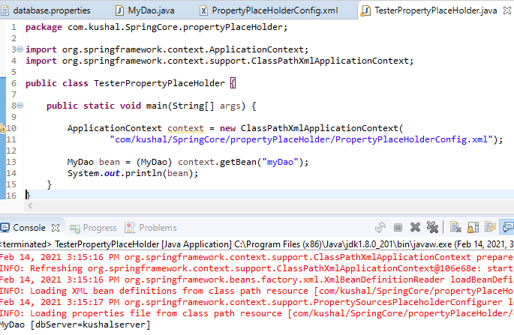

1. **BeanDefinatiotionStoreException** 🡪 In this if we try to use the property which does not exist in OR case-insensitiveness, then we will get BeanDefinationStoreException. 🡪 As shown in below we have modified the name as “**dbserver**” and we got the exception.

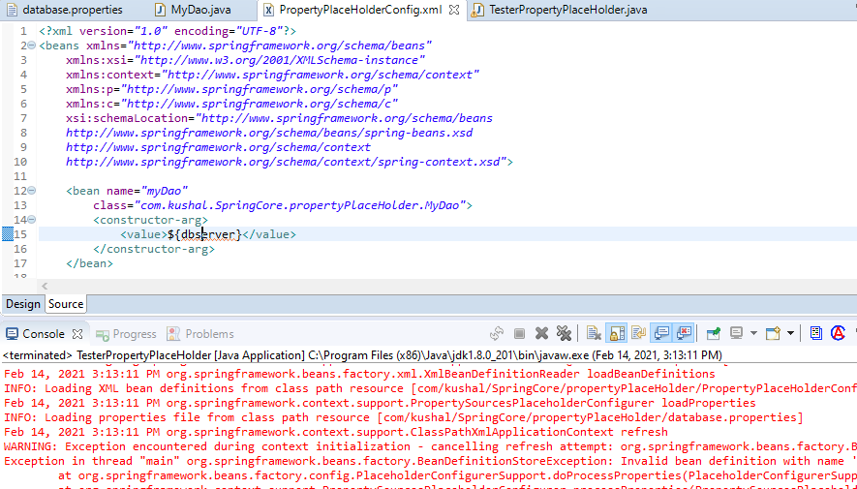

**Auto-Wiring**

When Object A depend on Object B to do it’s job, then Object B is dependency and Object A is dependent. We do the DI using setter and constructor injecting and using ref tag in config.xml to inject the dependency. So if this wiring is done by Programmer is called Wiring and if it is done automatically by Spring Container then it is called Auto-wiring.

<bean class=*"com.kushal.SpringCore.constructorInjection.Employee"* name=*"emp"* c:id=*"123"* **c:address-ref=*"address"*>** 🡪 In this c:address-ref tag is wiring by Programmer.

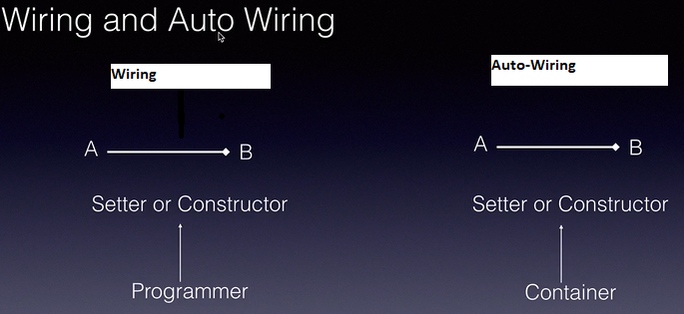

Auto-Wiring can be done in 2 different ways:

1. XML

* By default is NO(i.e. Disabled).
* We can do auto-wire **By Type, By Name, By Constructor.** In this by type and by name uses setter injection.

1. Annotation

* @Autowired and @Qualifier
* **In below Use Case we will do Autowiring using ByType** 🡪 In this Employee depends on Address

1. Create the Pojo class i.e. Spring Bean.

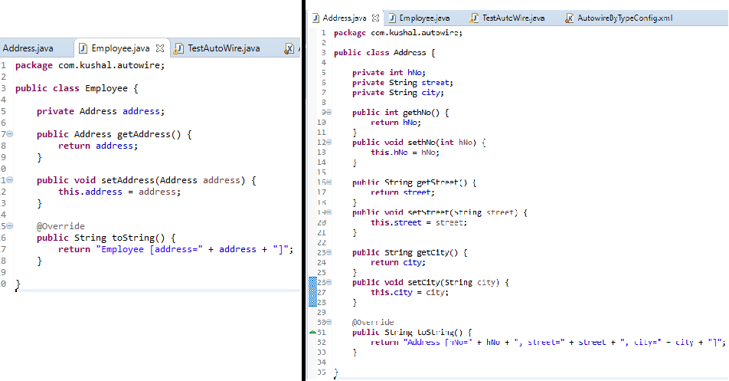

1. In config file we will do the DI of Address Pojo using setter injection, since in autowiring we will be using byType which internally uses setter injection.

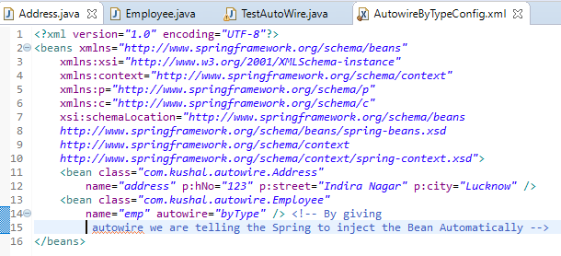

1. Tester class to run

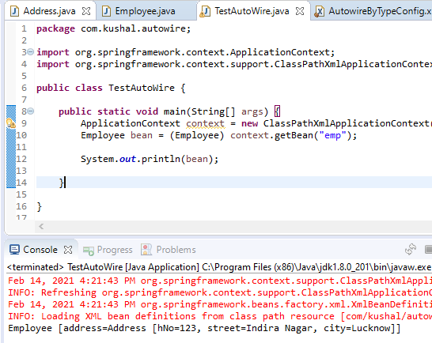

In this Spring container will invoke the XML file, then it will create the Address Object and Employee Object and when creating the creating the bean of Employee it see it has auto-wiring by type then it searches for all the Reference type present in Employee Bean and then it searches for the bean(by the class name) in spring config xml instantiate and create the object of that bean if it is not created.

3 Points to remember by using auto-wiring byType:

1. Spring will try to search for the bean type i.e. by Class if it finds it will inject it.
2. If we don’t declare the dependency bean and initialize it in Config file then Spring Container by default inject the null value, i.e. address reference in Employee class will have null value.

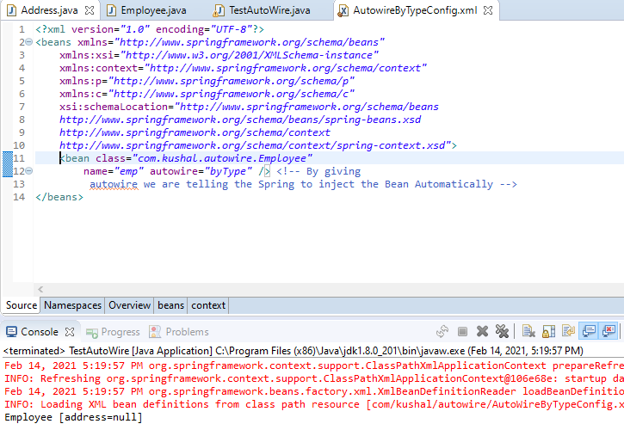

1. If we declare the 2 bean i.e. 2 Address bean inside the config file then Spring Container will throw Exception as **UnSatisfiedBeanDependencyException** as Spring container found 2 bean and required 1.

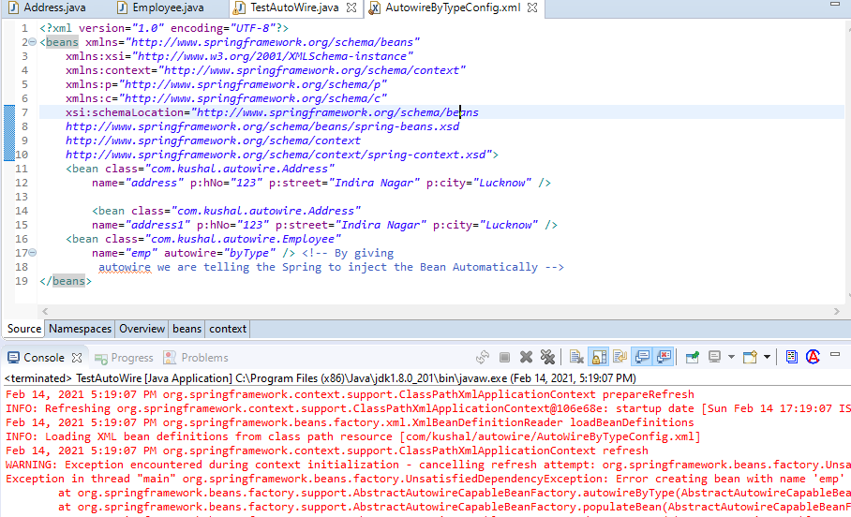

* **In below we are doing Auto-wiring byName**

In this we will modify the Config xml file value of attribute autowire will be byName 🡪 **autowire=”byName”.**

In this Spring container trying to initiate any bean and came across autowiring byName, it goes to Spring bean class and searches for all references type then it checks the config file for exactly the name of the bean which is reference variable name and then inject’s it. 🡪 **name="address"**

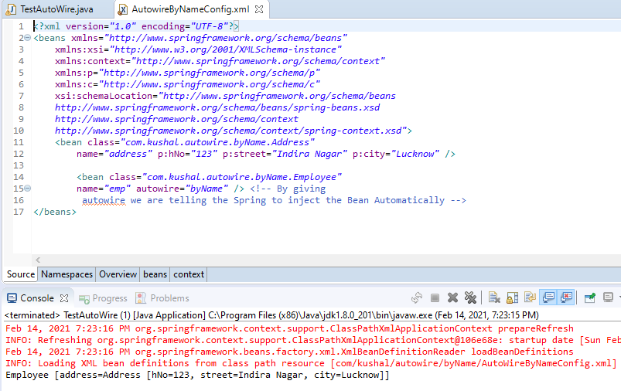

In byName configuration as well if we define the 2 beans with same name in spring config file then we would be getting **BeanDefinationParsingException.**

* **In below we are doing Auto-wiring using Constructor. 🡪** we are using below **autowire=”constructor”**

And in Employee bean we have created parameterized constructor for constructor injection.

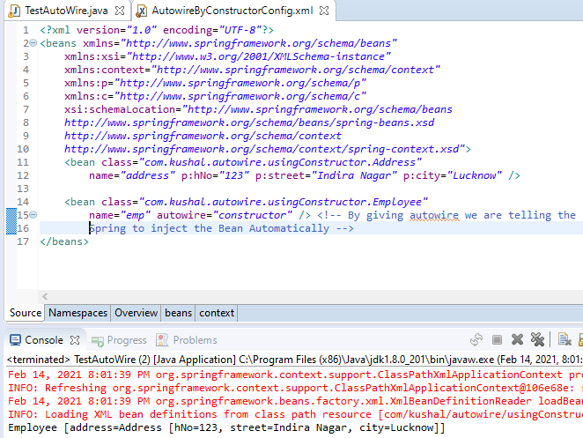

* **Auto-wiring using Annotation**

In this we will use @Autowired annotation for auto-wiring.

1. **Using @Autowired annotation at setter level**

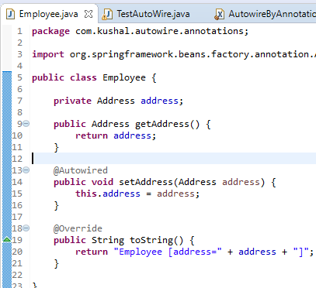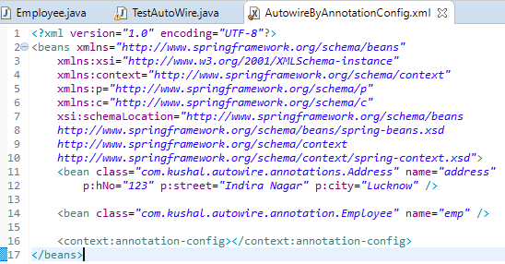Hence in Employee Spring we will use @Autowire annotation on the setter method of the Address as shown below:

1. Using **@Autowired annotation at field level 🡪** In this we we give the annotation at field level as shown below:

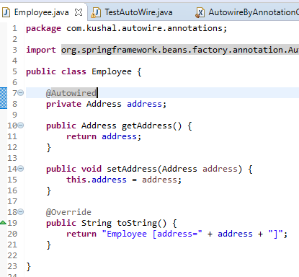

1. **Using @Autowired at constructor level 🡪** In this we give the annotation @Autowired

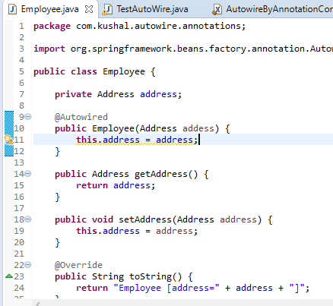

**Note 🡪 When we use the annotation @Autowired then if we don’t have bean with that name then it will give error as NoSuchBeanException, to avoid this and fill null if no matching bean is find then we should use attribute false at @Autowired annotation.**

1. **Using annotation @Qualifier 🡪** It used to tell the Spring container to find the bean using the name mentioned as parameter in @Qualifier annotation, if Container will not find such bean in config then it will throw Exception as **NoSuchBeanException,** if attribute is marked as mandatory i.e. attribute false is not marked on @Autowired annotation

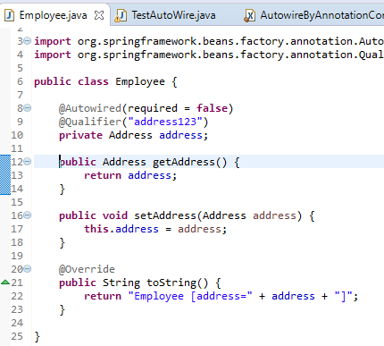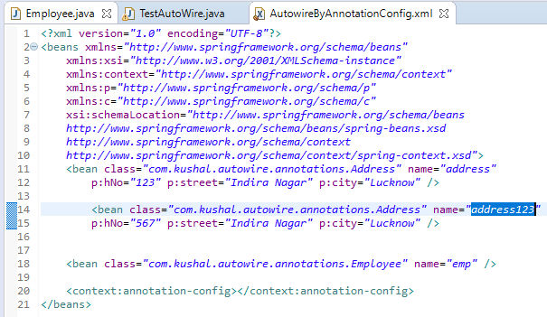

**Auto-wiring is the process of Spring container automatic injecting the reference type bean.**

**@Qualifier is must be used with @Autowired annotation.**

**Standalone Collections**

If we declare the list as below, then these list are local to bean and can used only inside these beans and we are using the default list i.e. ArrayList, To overcome this standalone collection comes into picture.

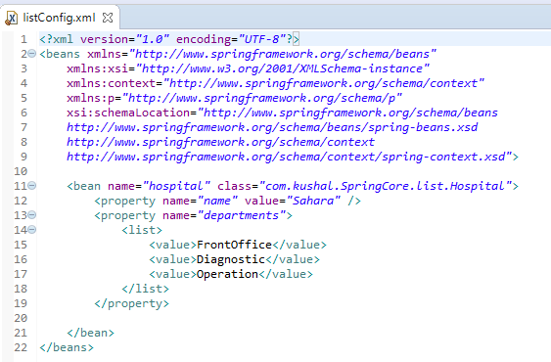

To implements Standalone Collections we will use **util schema 🡪** Below can be used where CN denotes Collection Name.

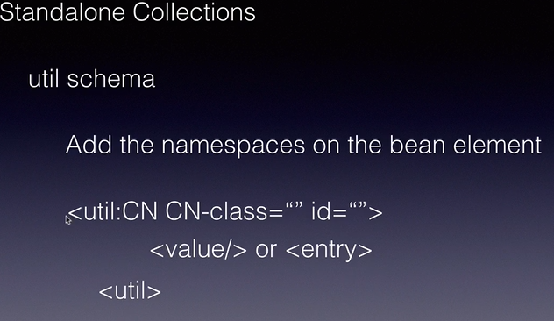

**Use Case: 🡪** In this we will create a separate list and use it inside the bean 🡪 list will be product List then we will inject into bean.

1. Create a Pojo i.e. Spring Bean ProductList which contains the list of products.

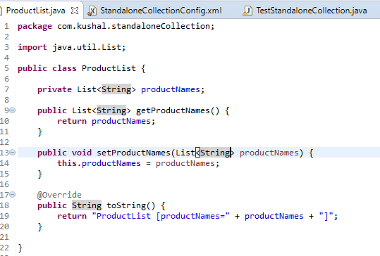

1. Create the Config file and create the standalone collection and use the reference type to inject into Bean.

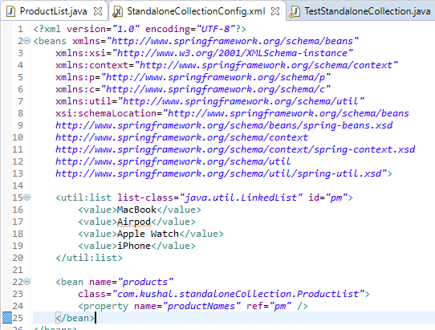

1. Tester class

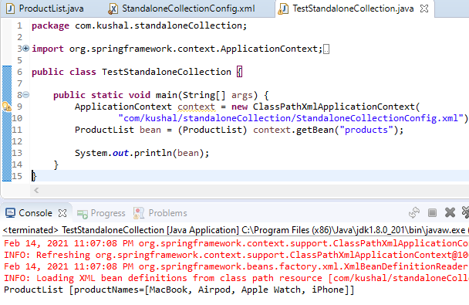

**Stereotype Annotations**

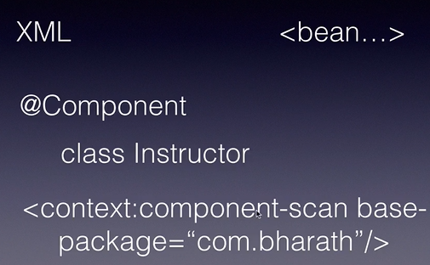In this we will learn how to create bean and inject them using annotations.

bean tag inside the xml is equivalent to @Component at class level.

In config file we will give **<context:component-scan base-package=”com.bharath”>,** by this it will scan all the component present inside the mentioned package and all it’s sub packages.

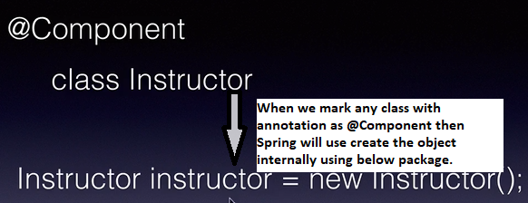

**Spring uses camel cases to name the reference variable of the object.**

1. Below is example we create the Pojo class i.e. Spring Bean and mark it with annotation **@Component**

By this Spring container will create the object with the **reference variable name as instructor.**

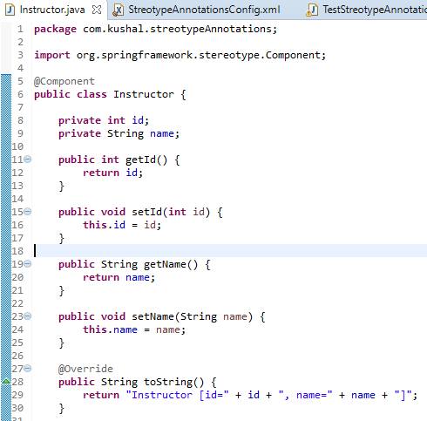

1. Create the configuration file and give the configuration to accept scan all the classes for components. 🡪 <context:component-scan base-package=*"com.kushal.streotypeAnnotations"* />

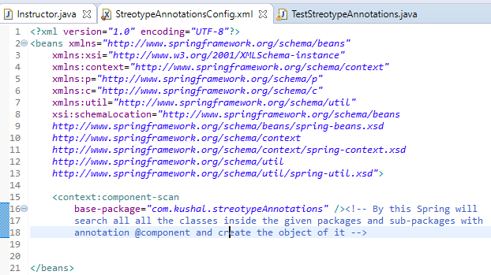

1. Tester Class:

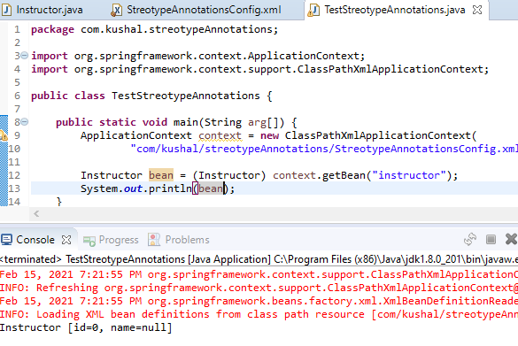

1. By default when we uses the @Component annotation uses the class name in camel case to name reference variable, we can change it by giving the value in @Component(“beanName”), now the name of the bean would be “**beanName**”.

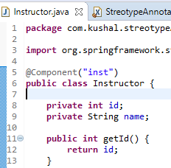

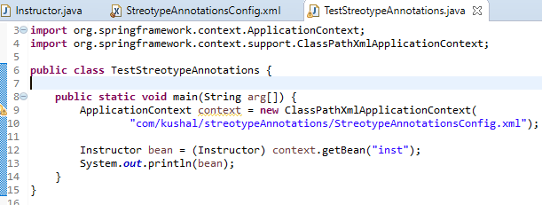

1. 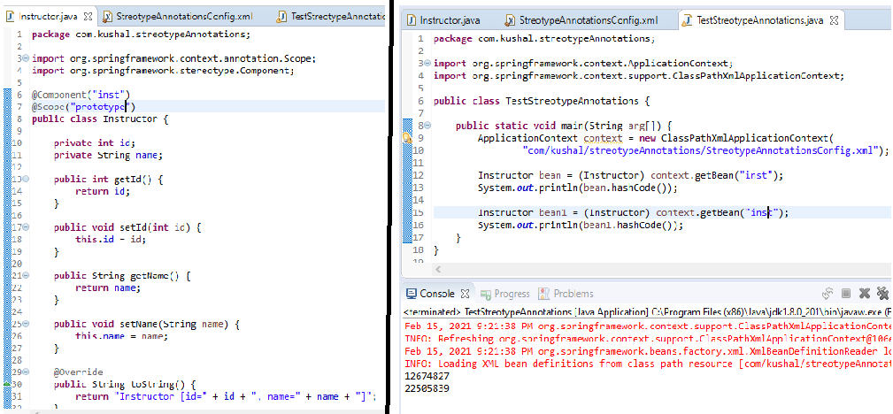To give scope of the bean using Annotation🡪 We can use the @Scope(“prototype”) to give the scope to the bean. @Scope annotation cannot be used alone and it is always used with @Component annotation.
2. To inject the value in the fields we can use the attribute @Value annotation.

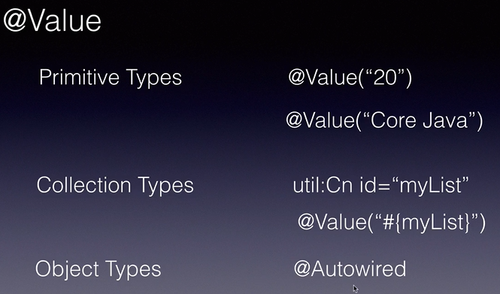

* Primitive Types: 🡪 We can give the values using @Value on field level that will be treated as default value and re-assign some other value according to the requirement as shown below:

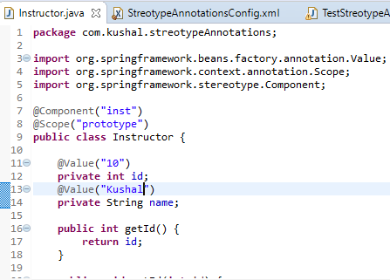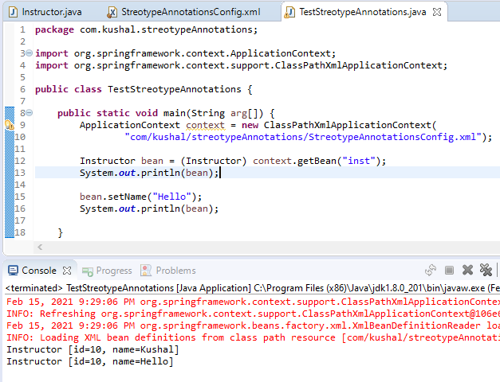

* Collection Types 🡪 IN this we will create the topics list in the Instructor bean and initialize it with @Value annotation. Then name “topics” given inside the @Value is name of id given in config file.

1. Create Pojo i.e. Spring bean:

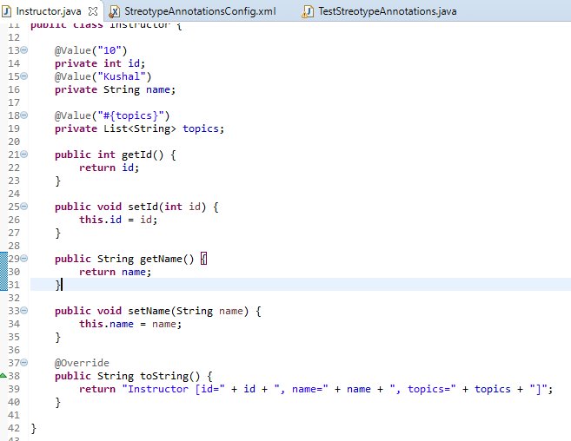

1. Creating Collection in Config file as below:

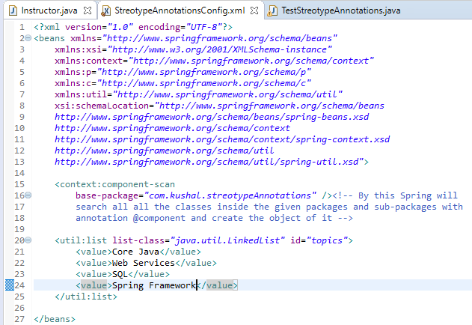

1. Tester class:

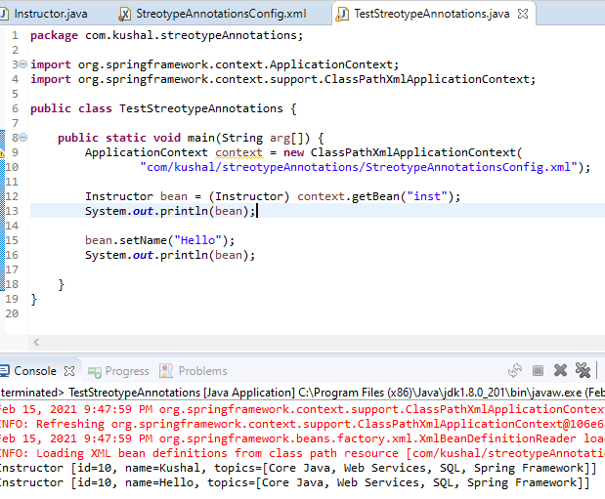

* Objects 🡪 In Objects type we use @Autowired to inject the object types and reference types.

1. In this we will have 2 Pojo i.e. Spring Bean Instructor and Profile. Inside Instructor we will use @Autowired annotation to inject Profile in Instructor.

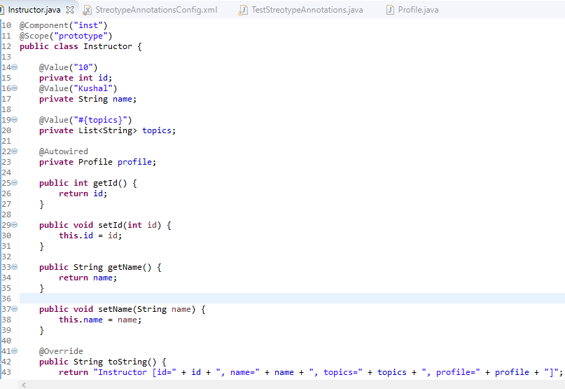

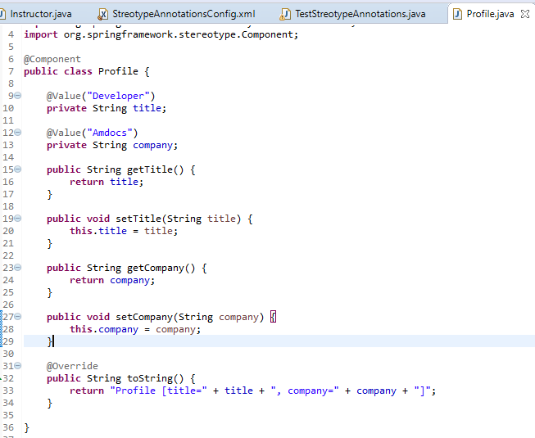

1. Configuration file

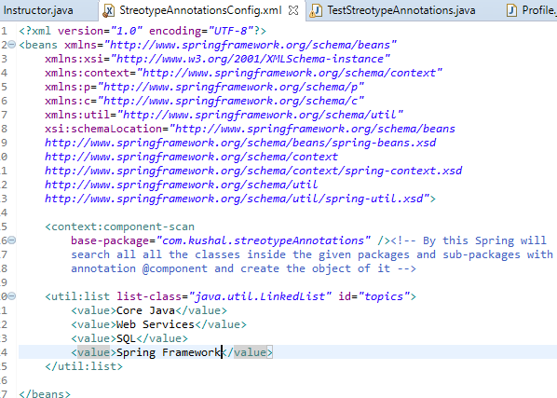

1. Tester class:

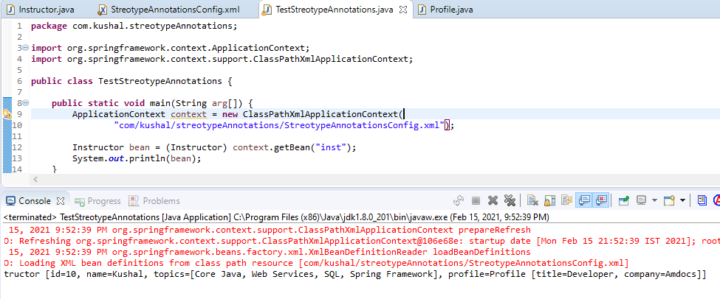

**Injecting the Interfaces**

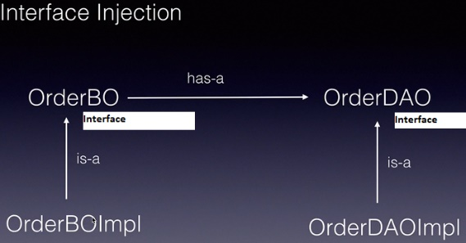

* Spring Framework does the interface injection using Runtime Polymorphism.
* If we declare the create the reference of Interface then automatically Spring will create the object of it’s implementation classes using Runtime Polymorphism

1. We created the 2 Interfaces OrderBo and OrderDao and 2 implementation classes as OrderBoImpl and OrderDaoImpl 🡪 So when we are injecting the order dao object into Order bo then Spring automatically creates the object of OrderDaoImpl even if we declare the reference of OrderDao.

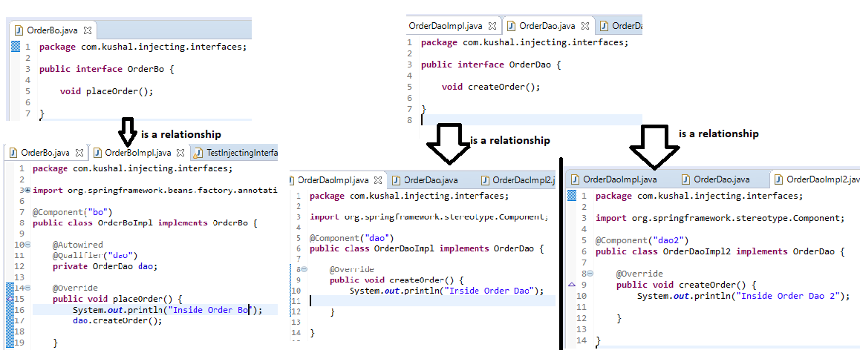In case there are 2 bean which are implementing the same interface then we need to use @Qualifier annotation on the @Autowired annotation and give the name of bean which needs to be injected, since 2 different bean both bean should have name given inside @Component annotation.

1. In above if we run the test class below: then since in OrderBoImpl when injecting the OrderDao using @Autowired annotation we have given the @Qualifier annotation name of bean declared in OrderDaoImpl @Component annotation, so Spring will create and inject the OrderDaoImpl using Runtime Polymorphism.

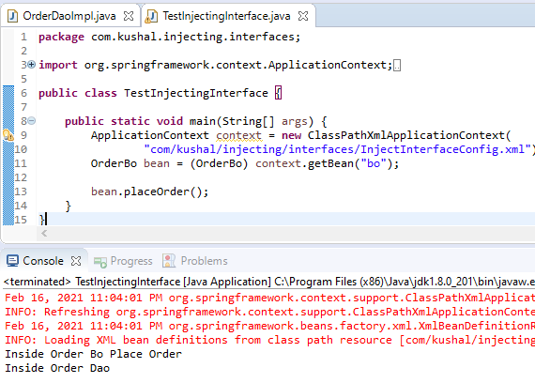

**Spring JDBC**

* Spring simplifies the use of JDBC, JMS, ORM.

In simple JDBC programming: 🡪 We create the Connection, prepared Statement, and then operate on resulteSet, This is done at many places i.e. in different classes in our project.

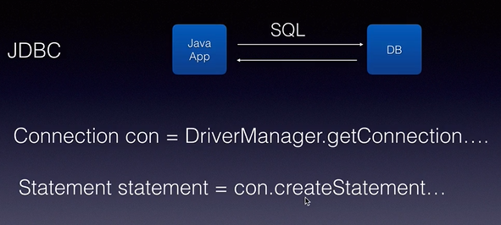

In Spring JDBC 🡪 It provides the Template which is called JDBC template : JDBC Template is combination of JDBC technology and Template Design Pattern.

Template contains all the common code which is required🡪 like username, password, env details, port.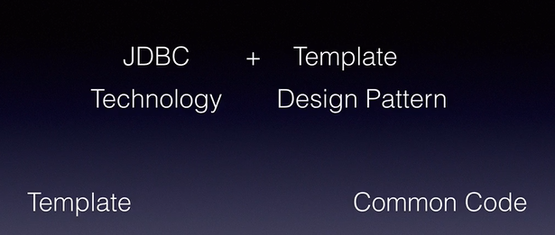

JDBC template depends on datasource (java.sql.DataSource). DataSource is a interface and Spring provides the implementation class as DriverManagerDataSource.

We will create bean of DriverManagerDataSource and inject this bean whenever we will require the JDBC template.

DataManagerSource contain’s 🡪 driverClassName, url, username, pwd and it is responsible to create the connection to DB.

JDBC template provides:

1. int update(String sql) 🡪 contains SQL statement
2. int update(String sql, Object … args) 🡪 SQL statement and parameter’s to replace the placeholder in SQL statement.

**In this usecase:**

Step 1: 🡪 Create employee table in myDB database. 🡪 Employee (int, firstname, lastname)

Step 2: 🡪 Create JDBC Maven Project with following dependency:

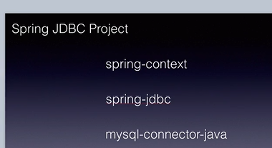

In pom.xml copy all the dependency and add the below dependency in the pom.xml

<dependency>

<groupId>org.springframework</groupId>

<artifactId>spring-jdbc</artifactId>

<version>${springframework.version}</version>

</dependency>

<dependency>

<groupId>mysql</groupId>

<artifactId>mysql-connector-java</artifactId>

<version>5.1.6</version>

</dependency>

Step 3: 🡪 Configure the DriverManagerDataSource and JDBCTemplate bean in Spring XML file, as these are pre-defined classes and configured in Spring XML file.

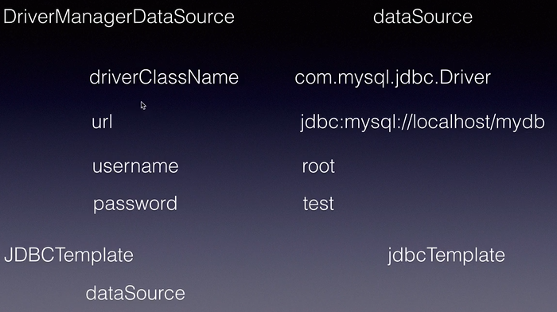

Below we need to configure the DriverManagerDataSource and JDBCTemplate.

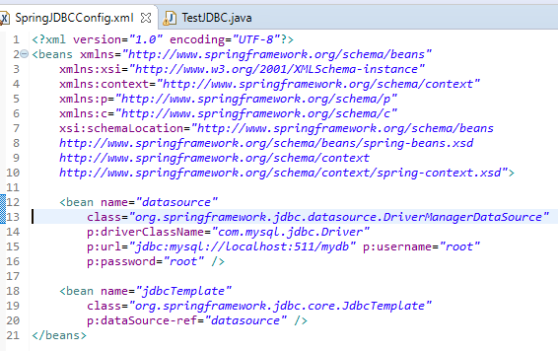

**Step 4**: 🡪 Create the Tester class and insert record in table Employee.

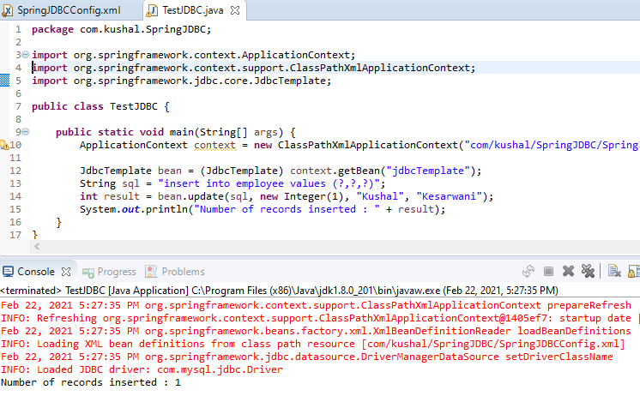

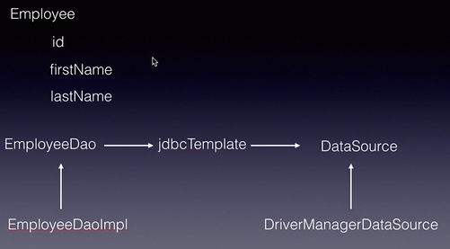Now in below example we will organize the application having DTOs and DAOs.

In the given example:

1. We have Entity or DTO called Employee which has same fields as in Table.
2. EmployeeDao and EmployeeDaoImpl to handle all database operation
3. JBBCTemplate 🡪 EmployeeDaoImpl will be injected in this.
4. DataSource and DriveManagerDataSource which is injected in Jdbc Template.
5. Create the Employee DTO or Entity.

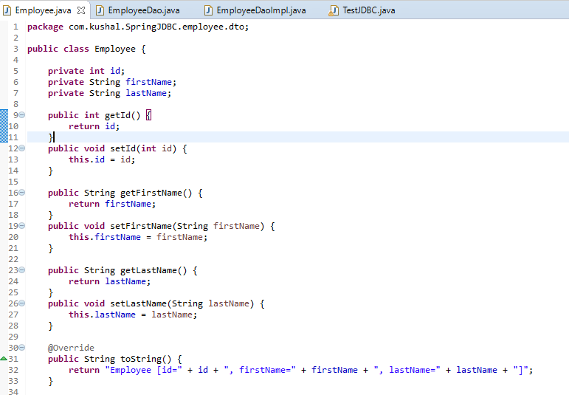

1. Create EmployeeDao interface and it’s implementation class.

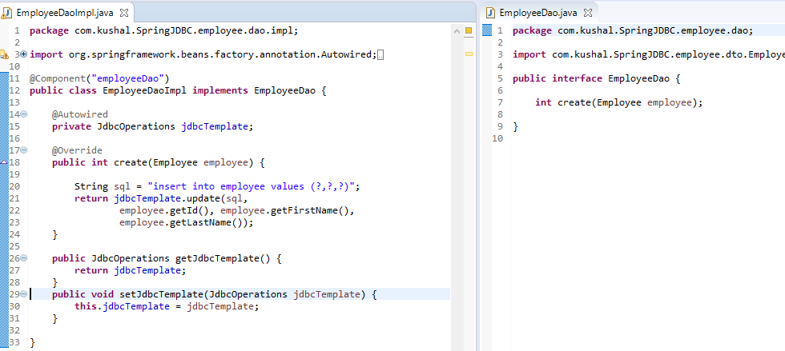

1. Create the config file as below:

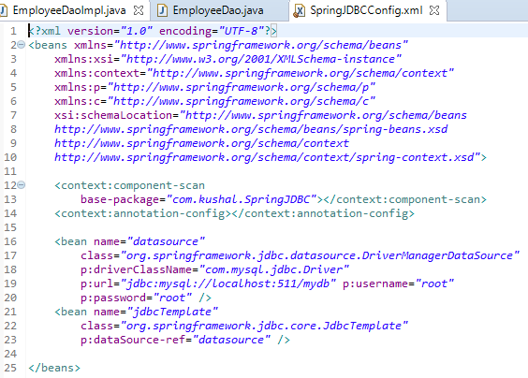

1. Test Class

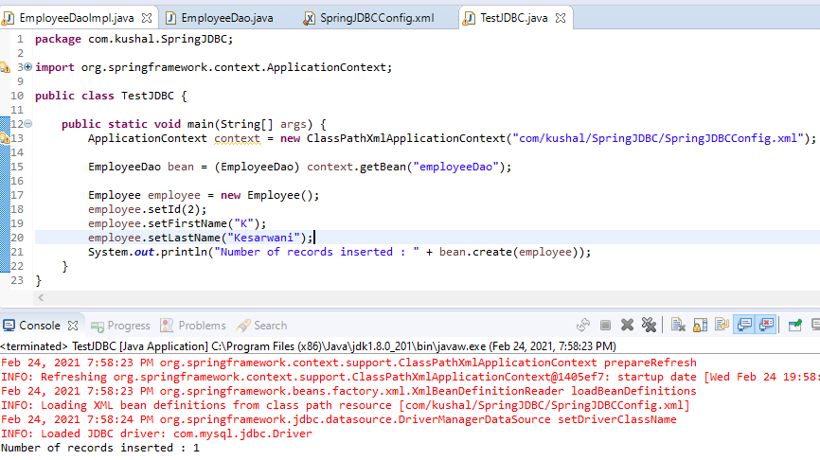

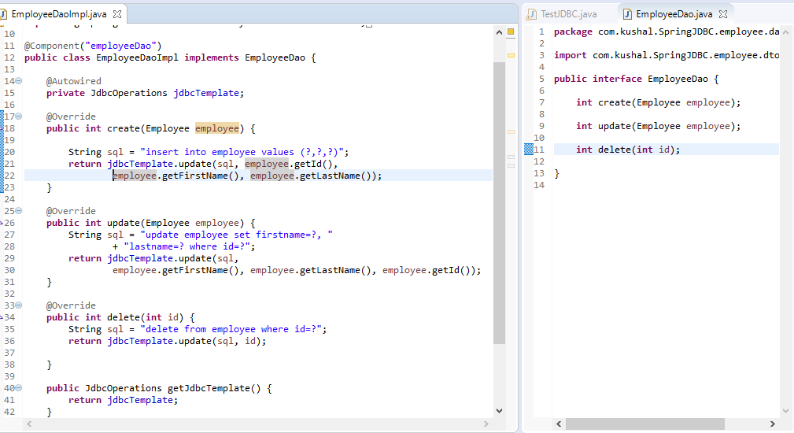Below is implemented for Updated and delete:

**Note** 🡪 When executing the delete Query if no rows returned then no of rows deleted will be zero and it will not throw any exception.

Below is provided by JDBC Template for Select Queries which returns single row and multiple rows:

In below 1 method return single row and second method returns multiple rows:

* Using select statement in JDBC Template.

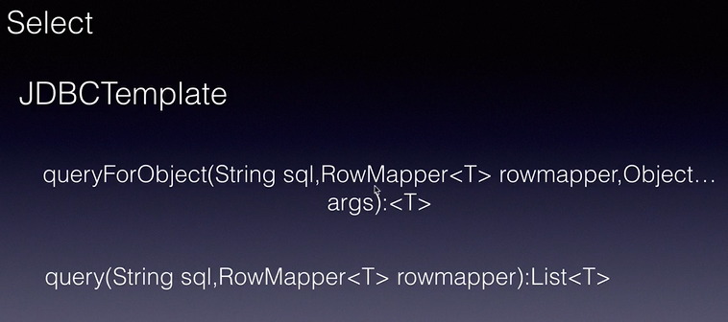

RowMapper is a interface in Spring Framework which is used to set the Result Set returned from the DB.

We need to implement the method mapRow() in implemented RowMapper implemented class.

Below is the architecture of it.

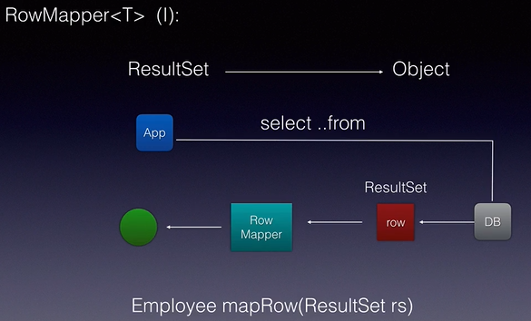

Below we create 2 new method read(int id) 🡪 to return single row and readAll() 🡪 to return all rows.

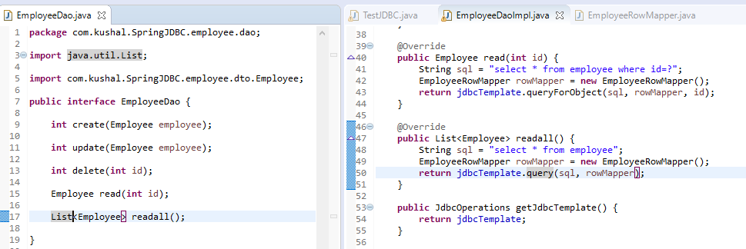

Below is RowMapper implementation:

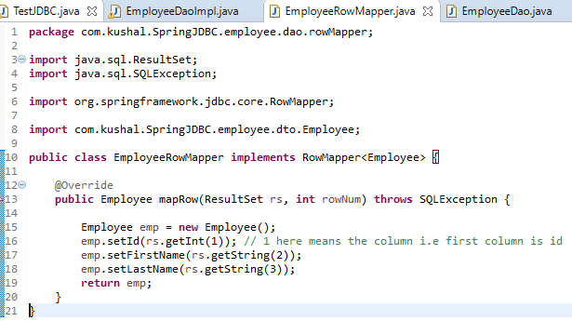

Below is the Test class which returns the result:

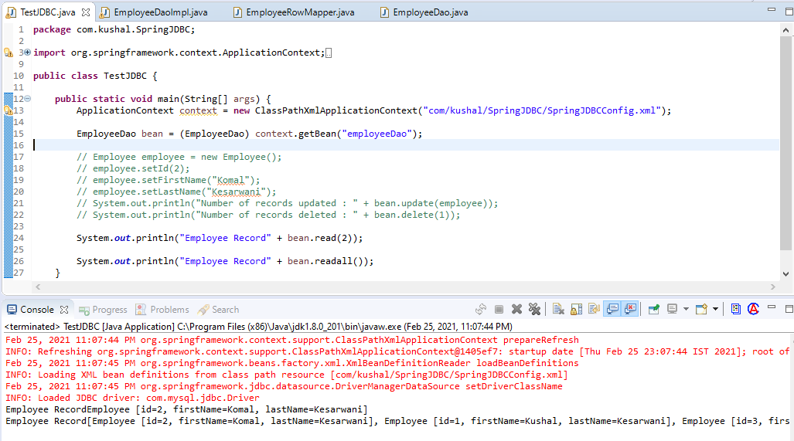

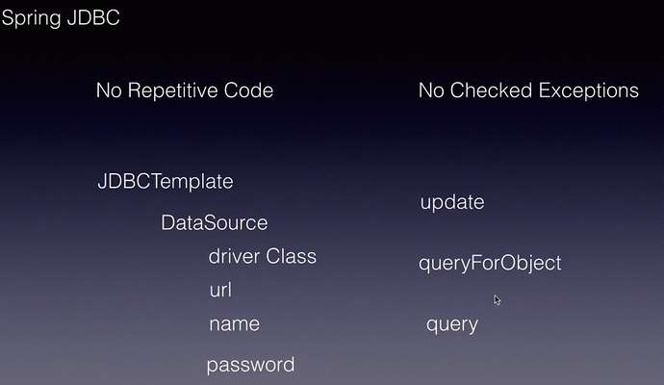Below is in Summary for Spring JDBC:

1. No repetitive code
2. We don’t need to handle any exception
3. We use JDBCTemplate which uses DataSource to give the details of the Database. When creating the Bean of datasource we need to provide the driverName, url and name and password.
4. We can use update() method for insert, update and delete and for select we would use queryForObject() for single object and query() for multiple records
5. We will use RowMapper interface to read the data, i.e. for select statement.

**Spring ORM**

ORM 🡪 Object Relational Mapping

In JDBC and Spring JDBC we create the SQL statement and process the result set in Java Object only the execution part is done automatically.

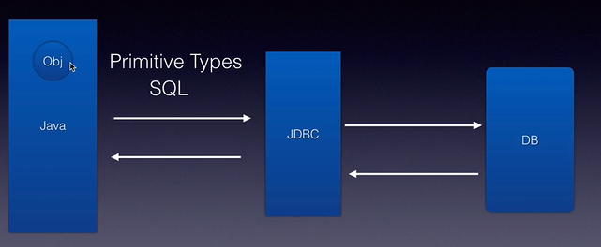

In ORM tool: 🡪 In this we create the Entity class which contains the same field as database column and we will provide the mapping between entity class fields and database column and ORM tool will create the SQL statement to insert, update Or delete the record as well it set the row in JAVA object. Each row in DB is equivalent to 1 object of the entity class.

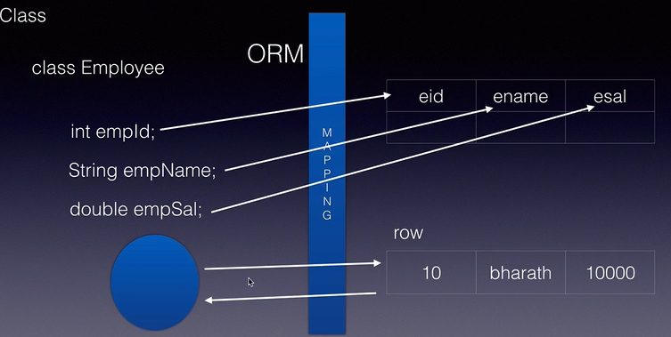

* JEE standard for doing ORM is JPA(Java Persistence API).
* API is for developer to use it.
* Specification is implemented by tool such as Hibernate is one of popular ORM toll which implements JPA specification.
* Some other ORM tool are EclipseLink and TopLink

**SpringORM**

* As Spring provides the JDBC template to ease the implementation of JDBC, Spring also provides the HibernateTemplate to ease the implementation of Hibernate.
* In HibernateTemplate it handle all the creation of session, etc and we can directly use the methods to save and get the data.

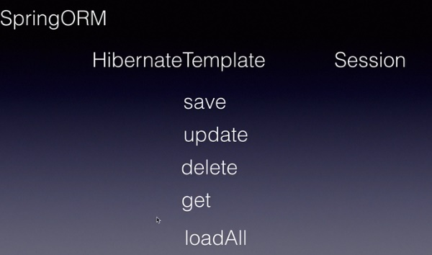

1. save() 🡪to insert the statement
2. update() 🡪 to update the save data
3. delete() 🡪 to delete the data from the table
4. get() 🡪 to get single row
5. loadAll() 🡪 to get the all the rows

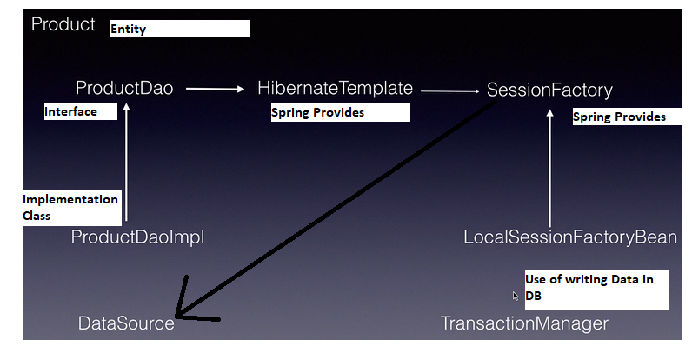

LocalSessionFactory bean depends on 3 other beans 🡪 dataSource, hibernateProperties, annotatedClasses

HiberateProperties is key : value pair as:

Hibernate.dialect = org.hibernate.dialect,MYSQLDialect (responsible to generate SQL statement)

Hibernate.show_sql =true 🡪 used to display SQL statement it is generating

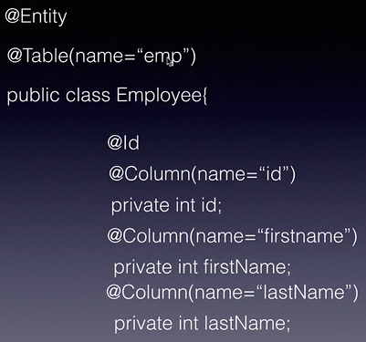

Below dependency needs to be given in pom.xml to fetch the dependency of Spring ORM.

We need to 2 dependency 🡪 Spring ORM and Hibernate Core.

<dependency>

<groupId>org.springframework</groupId>

<artifactId>spring-orm</artifactId>

<version>${springframework.version}</version>

</dependency>

<dependency>

<groupId>org.hibernate</groupId>

<artifactId>hibernate-core</artifactId>

<version>5.2.5.Final</version>

</dependency>

**Step 1:** 🡪 Create the entity class Product: Create the **Product** class use annotations: In below we have create the getter and setter methods also.

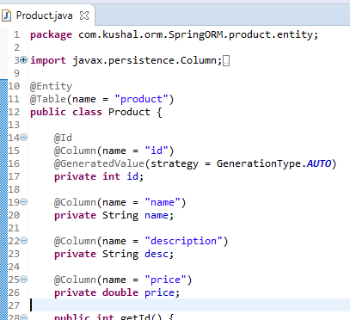

**Step 2:** 🡪 Create the Product Dao Interface and ProductDaoImpl.

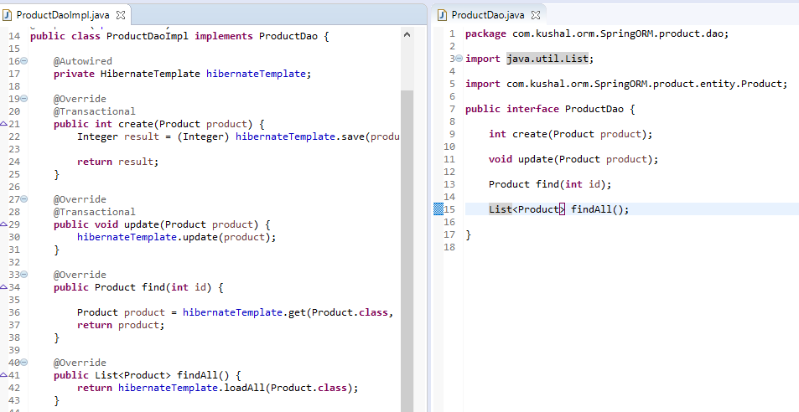Mark the ProductdaoImpl with @Component annotation and autowire the HibernateTemplate.

**Step 3:** **Transaction Manager** 🡪 In case when we need multiple things to be updated in DB, then we need to make sure the of the update is done OR none of them are done, then we use Transaction Manager, using commit and rollback.

**TransactionManager** is a interface which is implemented **HibernateTransactionManager** which is used in Hibernate.

We will configure this bean then configure annotation-driven and then we will use annotation for transaction and we need to mark the methods @Transactional annotation which uses Transaction, then Spring will configure the that method in single transaction so multiple update will be inside the transaction so if one fails all the transaction will be roll backed.

We need add the namespace for TransactionManager: **xmlns:tx="http://www.springframework.org/schema/tx**

http://www.springframework.org/schema/tx

http://www.springframework.org/schema/tx/spring-tx.xsd">

and configure the bean which has dependency of SessionFactory.

Step 4: 🡪 Create the configuration file

1. Configure Spring to use the Annotations
2. Create the bean of **DataSource** in which we need to provide the properties for MySQL database connection details
3. Create the **LocalSessionFactpryBean** bean which has reference property of “**dataSource**” and provide the list of **hibernateProperties**(**hibernate.dialect, show_sql**), create the property of **annotatedClasses** which has value of all the entity class.
4. Create the HibernateTemplate bean in which we inject **sessionfactory** ref.
5. Configure Transaction Manager bean.

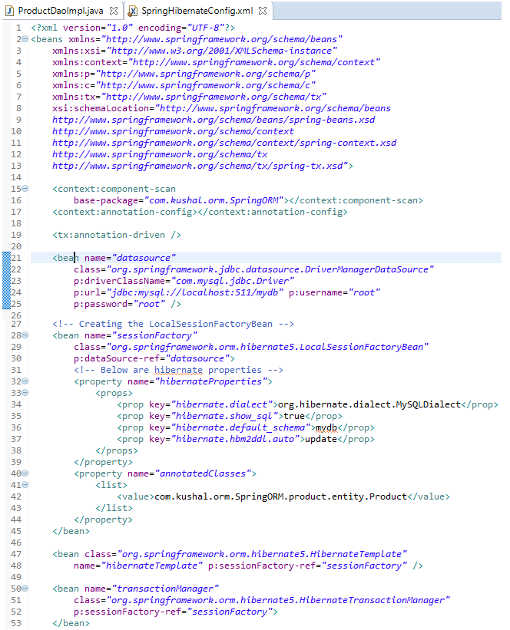

**Step 5:** Test Class

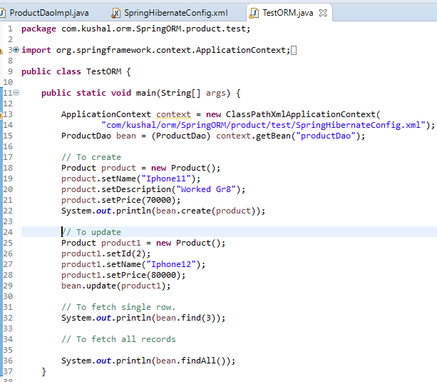

Summary of Spring ORM

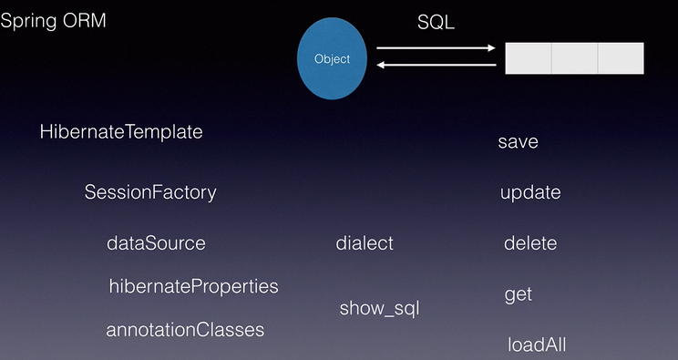

**Spring MVC 🡪** is used dynamically web application.

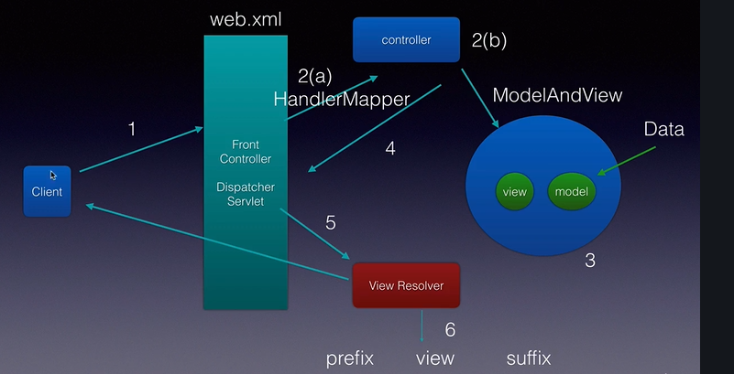It internally uses 3 different Design Patterns 🡪 Front Controller, Handler Mapper, View Resolver.

In the Diagram Client request comes to DispatcherServlet (provided by Spring), then Dispatcher Servlet calls HandlerMapper and according to the URL HandlerMapper invokes the Controller, Controller is a POJO with annotation as @Controller and Controller creates the Model and View (Model is not necessary) depends on the data, but returns the View name, View name is the given to View Resolver, then View resolver add the prefix(location of the view) and suffix(type of the view i.e. jsp, js OR jsf) and then View Resolver loads the next page to the client screen.

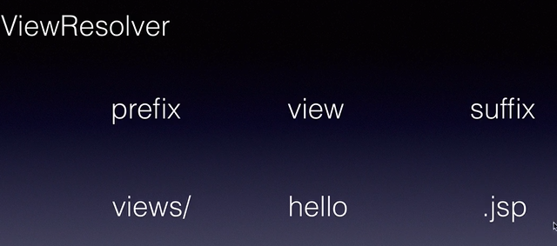

Suffix will be configured in the Spring Configuration file.

* **Spring MVC Maven Web Application. (05SpringMVC)**

When creating the maven project use the archetype as “**maven-archetype-webapp**” since we are creating the Maven web application.

In Pom.xml delete all the dependency and add only below dependency

<dependency>

<groupId>org.springframework</groupId>

<artifactId>spring-webmvc</artifactId>

<version>${springframework.version}</version>

</dependency>

After this we can see error in index.jsp page, we can remove it in 2 ways:

1. Add the Servlet dependency in pom.xml
2. Configuring the Apache as target runtime. This can be done in Project 🡪 buildPath🡪 targetRuntime 🡪 select Apache Tamcat server.

**Step 1:** Configure **DispatcherServlet**

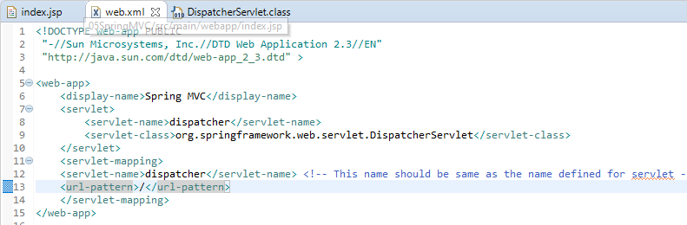

**Step 2:** Create the Spring Configuration 🡪 We need to put the Spring configuration XML file under the web-inf folder and name should follow the pattern “**servletName-servlet.xml**” i.e., dispatcher-servlet.xml

**Step 3: Configure the View Resolver 🡪** View Resolver is Java class which is used as bean and is used to resolve the location which is prefix and suffix which is type of extension for us.

Spring framework provides us the bean for View Resolver 🡪 “org.springframework.web.servlet.view.InternalResourceViewResolver”

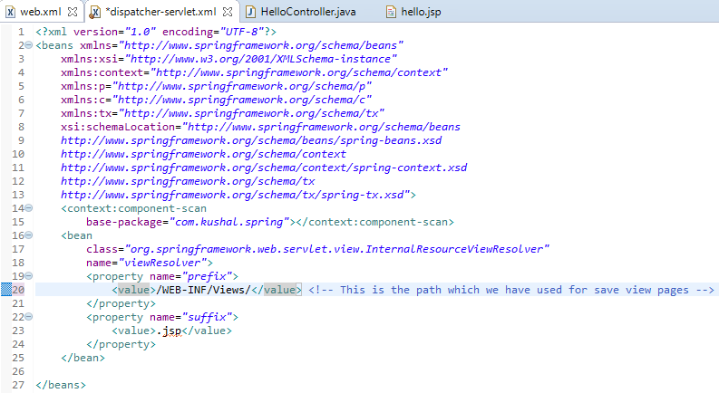

**Step 4:** Create the Controller 🡪 For a class to be controller we need to create the annotation @Controller to tell Spring this class is the controller class and bean can be created. We need to mark the every method with @RequestMapping and give the url to tell Spring which URL it should be invoked.

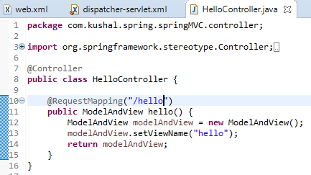

**Step 5:** Create the folder Structure and View

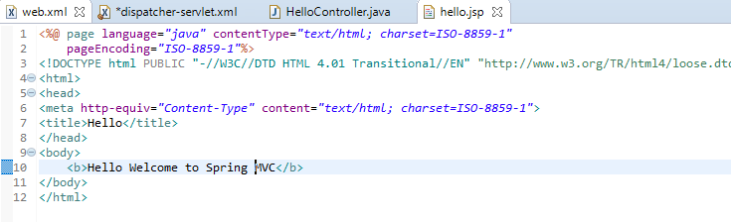

**Step 6 🡪** When Running the Application we would see Hello World which is configured in index.jsp.

We need add the hello to launch the hello.jsp page.

<http://localhost:2507/05SpringMVC/hello>

**Flow patter explained below**

When we launch the Server it will go to web.xml, since we have configured to take all the request we have given “/” in url-pattern so it will scan all the packages.

RequestDispatcher will take the request and dispatch to HelloController and the method “hello” for which matched the URL pattern, and this Controller returns the modelAndView containing the view name as “hello”, then controller will invoke the InternalViewResolver and it will give it “hello” and then it will append “.jsp” to suffix and location to prefix and return to the controller and then controller will take the JSP and execute the JSP and sent the response to Web Browser.

**Section 17 🡪 Sending Data from Controller to UI**

We send the data from Controller to UI using ModelAndView object.

We send the data from Controller to UI using method addObject(key,value) and get on the JSP page using request.getAttribute(“key”) on UI.

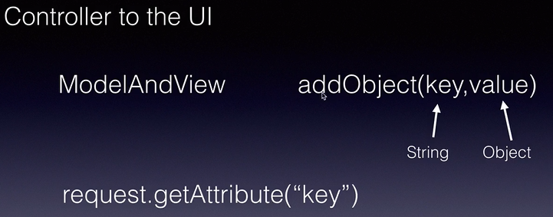

“value” 🡪 in the addObject can be of primitive type, Object type, Collection type.

* In below are passing the primitive data from Controller to UI.

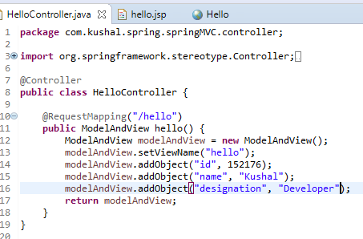

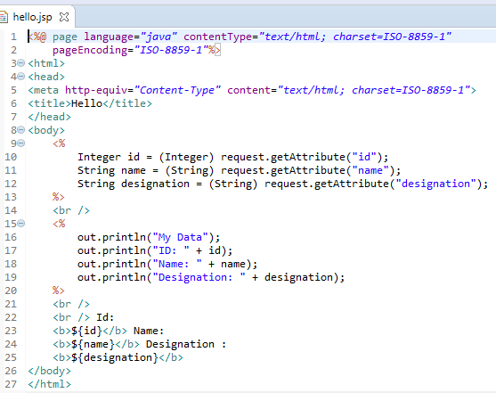

Remember when using JSP Expression language we need to remove the Doc type tag mentioned in the JSP page top

* **In below passing the Object Types.**

**Step 1 🡪 Create the DTO:**

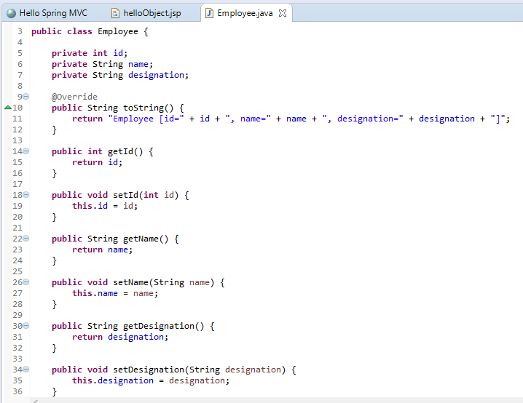

**Step 2: Create the new Controller:**

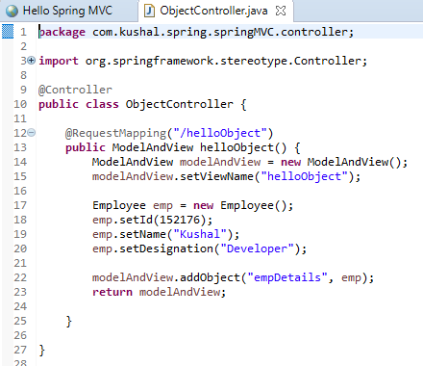

**Step 3: Create new JSP page.**

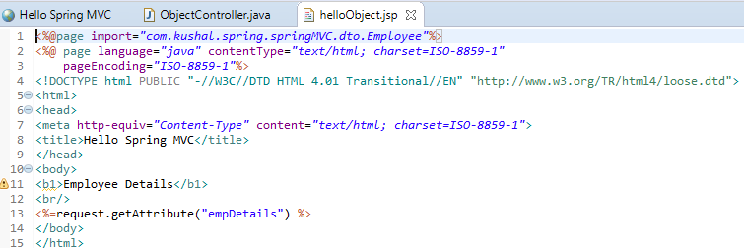

Note 🡪 After every change clean the server, then run maven clean, maven install and run the project on server, Else face issue the changes will not be reflected correctly.

* **In below we now use List**

**Step 1: Create the Controller:**

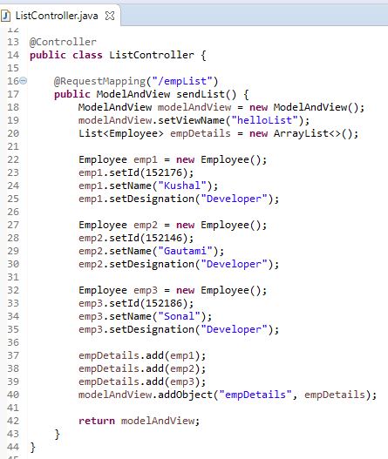

**Step 2: JSP Page**

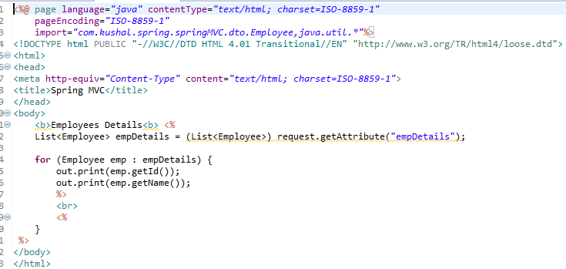

**Section 18: Sending the Data from UI to Controller**

This can be done in 2 ways 🡪 HTML form, Query Parameters

1. **HTML form**

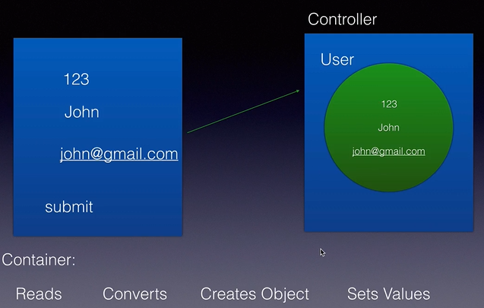

When HTML form is submitted the Spring read the data from the Client and converts it into the Data Type and then creates the Object and set values and handover the Object (i.e. Model to Controller).

To get the above things to work we need to create the POJO class in which number of fields should match no of field in HTML form and name of the field should also match.

We use **@ModelAttribute** annotation at method parameter to read the values in Controller.

**In this we will do User Regitration use Case to implement above**

IN which we will create 2 methods :

1. Will return the userReg.jsp and then we will enter the data on the HTML form on the browser and submit it, then it will be directed to controller method in which we would have @ModelAttribute to map the fields.

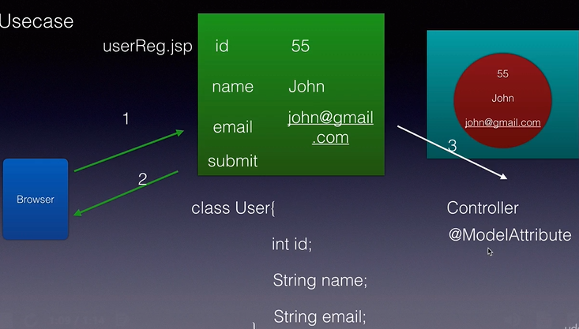

Refer Project 🡪 06SpringMVC_SendingDataUI2Controller

Step 1: Create the we web.xml and configure Dispatcher Servlet.

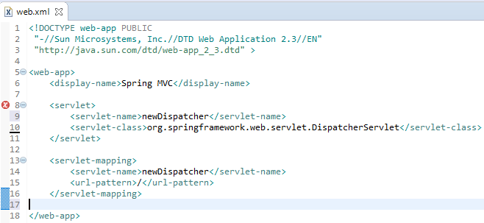

Step 2: Create the Spring Configuration file 🡪 newDispatcher-servlet.xml

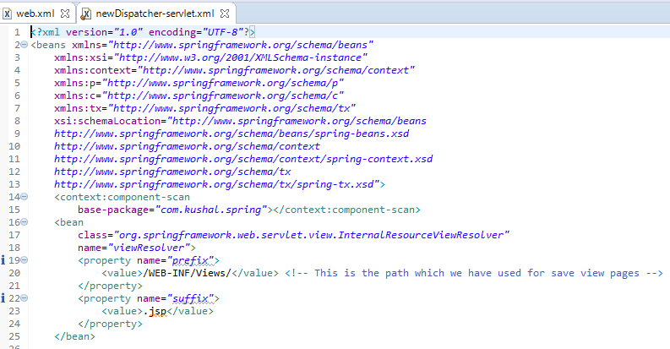

Step 3: Create the DTO (User) which have the fields id, name, email.

Create the getter and setter of all the field and generate the toString() method.

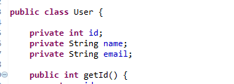

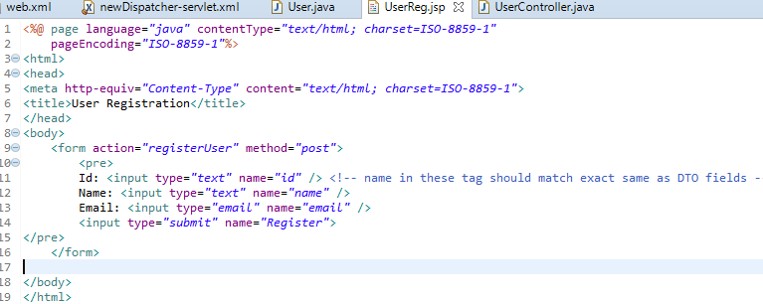Step 4: Create the User Registration View page 🡪 UserReg.jsp

In this the action should be same as given in the RequestMappping annotation in controller and name of the field should be exactly same as the name of field given in DTO.

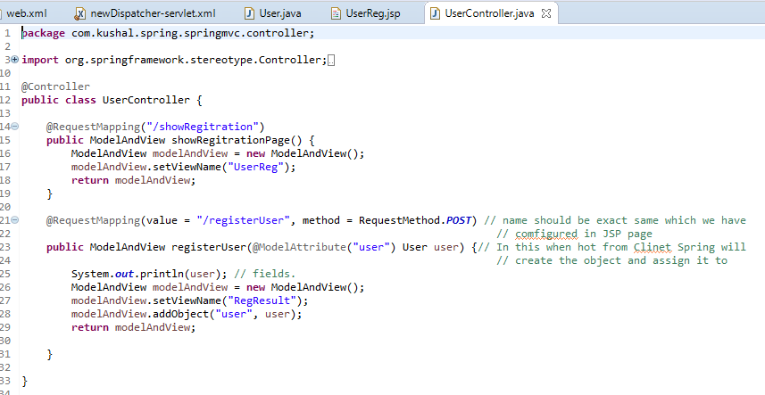Step 5: Create the Controller class

In this first method showRegistration method is used to open the UserReg.jsp page.

And the second method registerUser RequestMapping should match exactly the same as given in HTML form. And we setting view as RegResult showing Registration as successful.

Step 6: RegResult.jsp which shows the data inputted by the user.

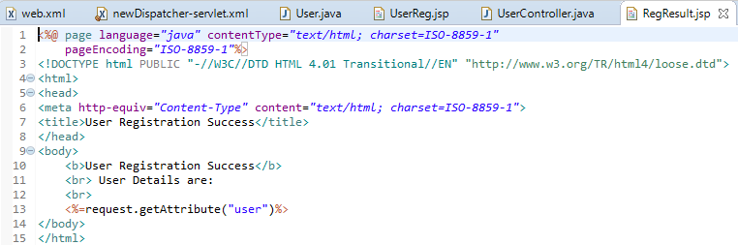

1. 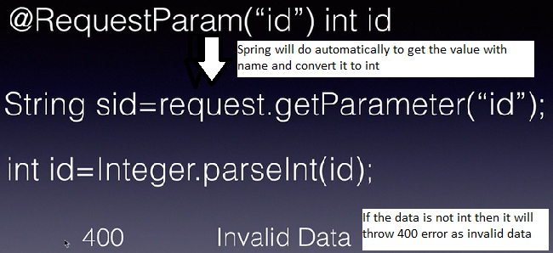**Using Query Parameters OR Request Parameter**

In the controller we will use @RequestParam to get the value passed from UI.

If field is not mandatory then we need to mark it false as by default it is true and we can also give the default values if the value doesn’t come in the request.

Order doesn’t matter in the request and in the method argument.

Now we create new Controller:

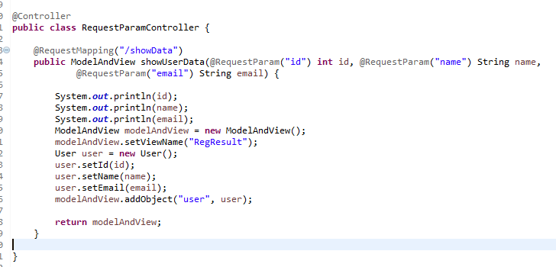

Then run the application and change the user as below, if we miss any param in the below URL we will get 400 as by default all the parameter is required.

If we need to make some parameter as optional then we need to enhance above by using attribute **required=false.**

**http://localhost:2507/06SpringMVC_SendingDataUI2Controller/showData?id=123&name=Kushal&email=kushal**

Since it is not required to have data in response i.e. we require only View and Model is not required hence in later ModelMap and View are separated.

So in above page when showing the User Registration Page we are only showing the User Registration Page and we are not sending any data.

So showRegitration() method in UserController can be modified as below, to just use View and no use of Model.

In below we are separated ModelAndView 🡪 For Model we used ModelMap and we are returning the view directly. By below it help us to easy code and not tightly coupled.

ModelMap has method 🡪 addAttribute to sent data back to UI.

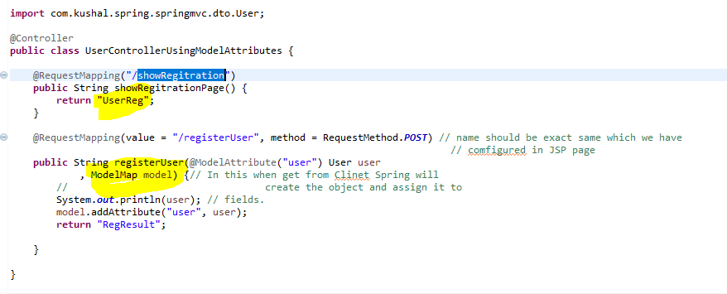

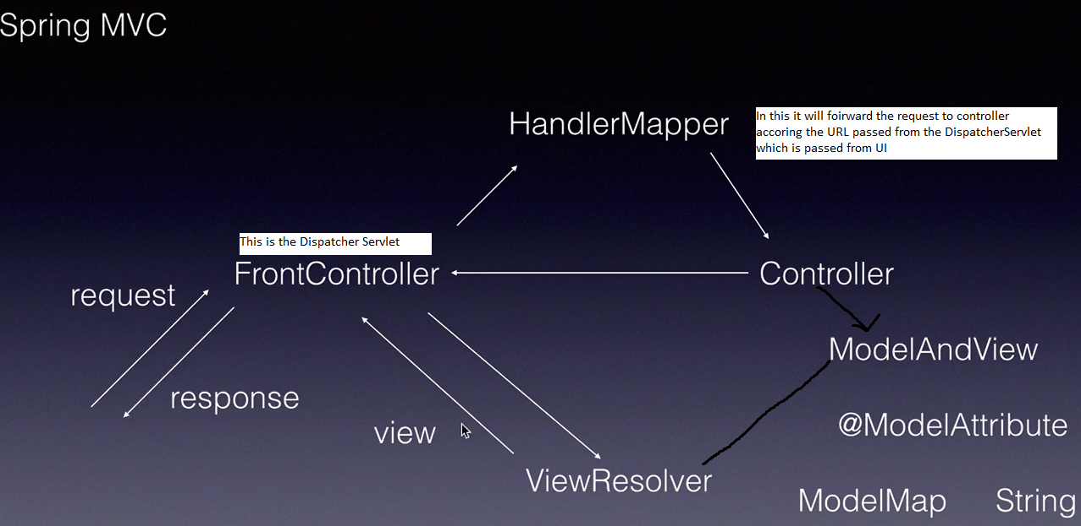

**Section 20 🡪 Spring MVC with ORM**

**UseCase 🡪 UserRegistration**

Step 1: Create the maven Project with below dependencies

<dependency> **// Spring MVC Dependecy for Front Controller**

<groupId>org.springframework</groupId>

<artifactId>spring-webmvc</artifactId>

<version>${springframework.version}</version>

</dependency>

<dependency> **// Servlet Dependency**

<groupId>javax.servlet</groupId>

<artifactId>servlet-api</artifactId>

<version>2.3</version>

<scope>provided</scope>

</dependency>

<dependency> **// Spring ORM Dependency**

<groupId>org.springframework</groupId>

<artifactId>spring-orm</artifactId>

<version>${springframework.version}</version>

</dependency>

<dependency> **// Hibernate Core Jars**

<groupId>org.hibernate</groupId>

<artifactId>hibernate-core</artifactId>

<version>5.2.5.Final</version>

</dependency>

<dependency> **//My SQL Connector Dependency**

<groupId>mysql</groupId>

<artifactId>mysql-connector-java</artifactId>

<version>5.1.6</version>

</dependency>

Step 2: Configure the DispatherServlet in web.xml file.

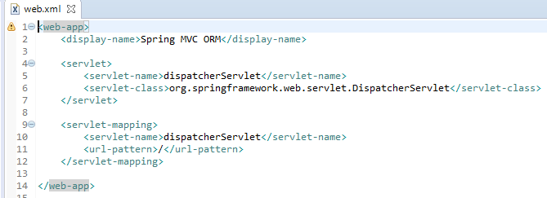

Step 3: Configure the dispatcherServlet-servlet.xml with HibernateTemplate and Session Factory and DataSource and ViewResolver.

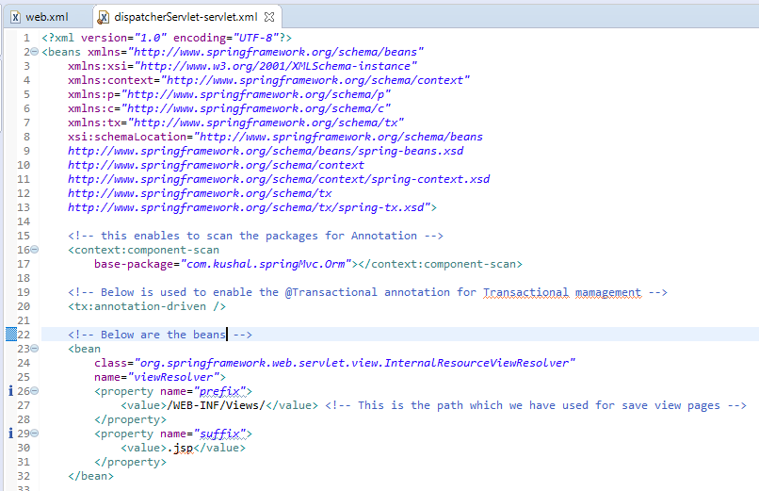

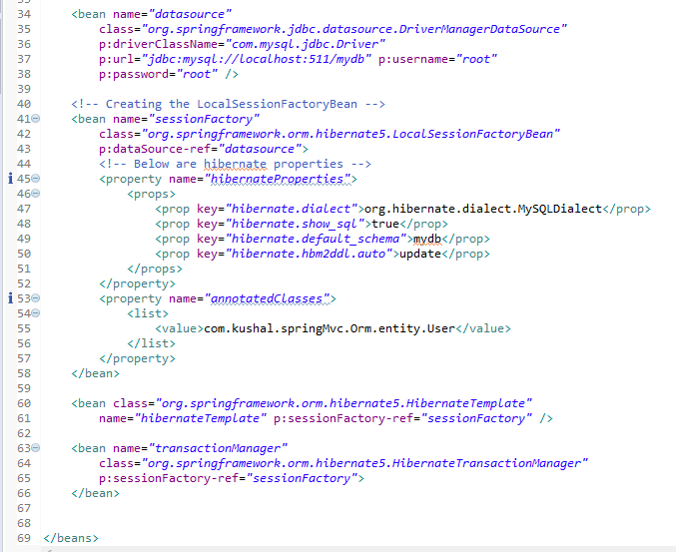

Step 4: Create Model Class and Create Data Access Layer and Create the Service Layer Class and Controller Layer OR UI Code. 🡪 In below the classes within the layer has **is-a** **relationship** and across the layer shows **has-a relationship.**

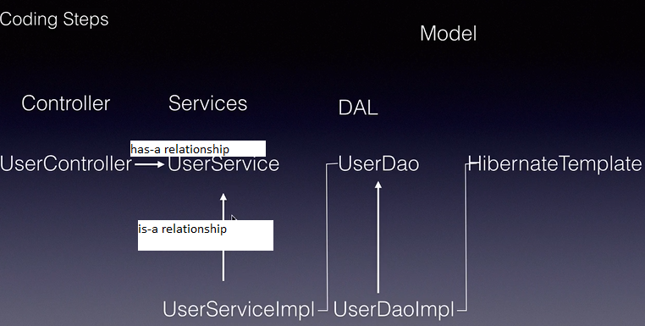

1. Create the Model Class i.e. Entity

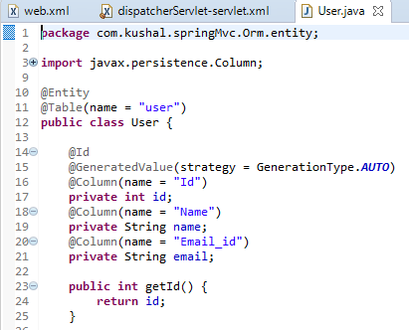

1. Create POJIs and POJOs i.e. UserDao

**Dao Layer** 🡪 For the Dao layer class, we need class with annotation as **@Repository** from Spring, as in this class we will do all the Database related transaction.

Inside UserDaoImpl we need to create the Object of HibernateTermplate as shows in above diagram UserDaoImpl depends on HibernateTemplate.

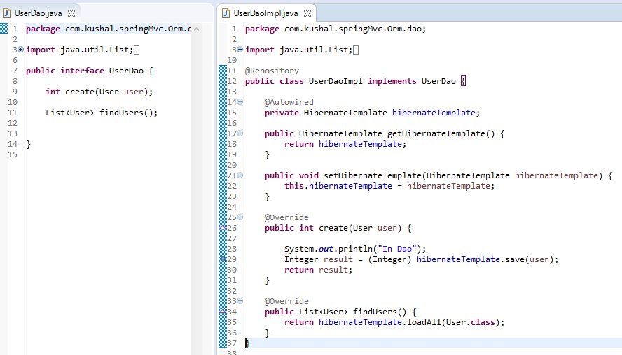

**Service Layer** 🡪 For Service Layer, we need class with annotation **@Service** from Spring.

Inside UserServicesImpl we need to create the Object of UserDaoImpl as shown in diagram as UserServiceImpl depends on UserDao for database transaction.

The methods in the Service layer need to marked with @Transactional annotation if we saving the data.

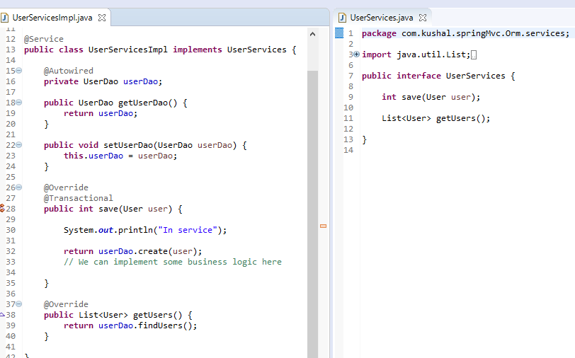

**Controller Layer** 🡪 For Controller Layer, we need class with annotation **@Controller** from Spring and this depends in UserServicesImpl.

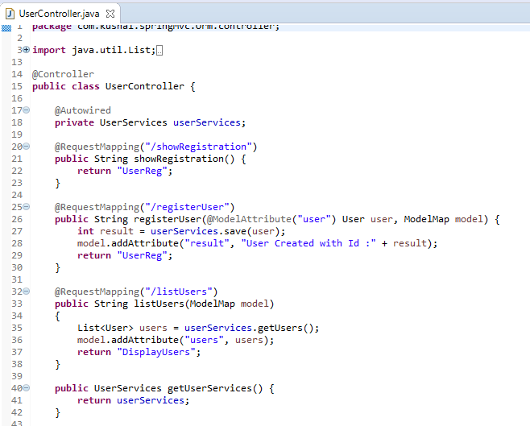

Step 5: Create the View Pages.

In this we have 2 views pages as view in the Controller layer 🡪 UserReg.jsp and DisplayUsers.jsp

In UserReg.jsp form the name of action should exact match with the RequestMapping in Controller class

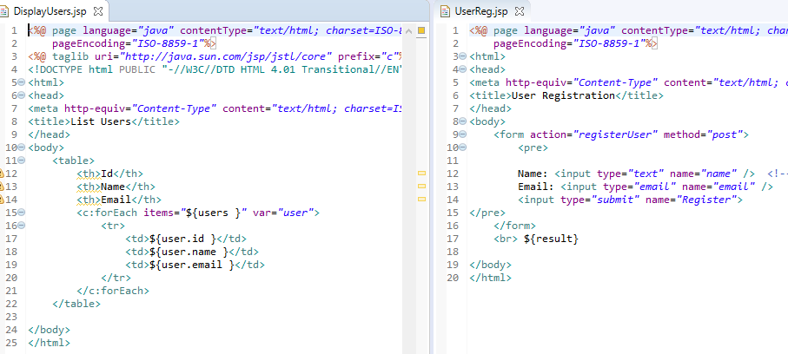

**Flow Chart of the above UseCase**

From the userReg.jsp Client page flows to Controller and goes to Controller method “registerUser” and Spring automatically map the client field to Model Map from it is goes to ServiceLayer 🡪 DaoLayer 🡪 Back to ServiceLayer 🡪 Controller and ViewResolver and displays the Id of the saved User of the same Page.

Note 🡪 Eve though we marked the @Autowired annotation at Interface Spring will create the Object of the Implementation class Internally using Runtime Polymorphism if we have 2 class with same name then we need to use annotation @Qualifier and using the name on the implementation class level also using @Qualier annotation.

**Spring AOP(Aspect Oriented Programming)**

It is sued to add TransactionManager, Logging Security in our classes without modifying our classes.

These are External Services which are added some features without effecting the classes and it is also known as **Cost Cutting Concerns** because they can be applied across the layers in Java Web Application.

The injection of These plugin like TransactionManager, Logging Security without changing the class is called AOP.

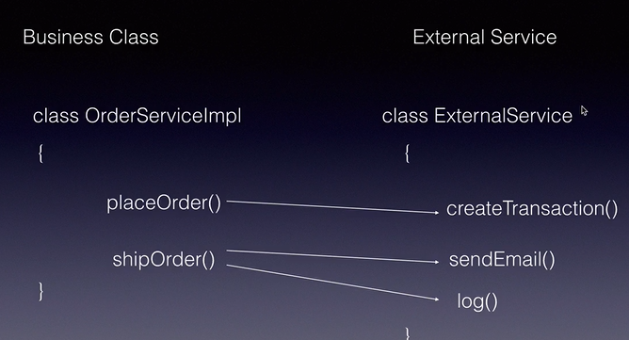

**AOP Terminology:**

**Aspect** is a class which represents External Services

**Advise** is the method define inside the Aspect class, it is also known as the implementation of the aspect.

**PointCut** it is regex which we tell which all method in our Service needs advises.

**JointPoint** is combination of Advise and PointCut, it will advise which business method needs which advise.

**Target** is the Object of the Business class which needs advises.

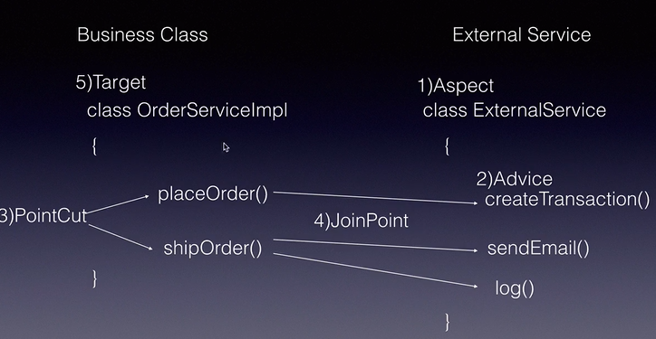

**Weavinig** It is applying of advises to target object based on the joint points.

**Proxy** It is class which is generated as the Weaving process. It contain Business logic as well as the Advise logic.

**Weaver** is a component responsible for Weaving.

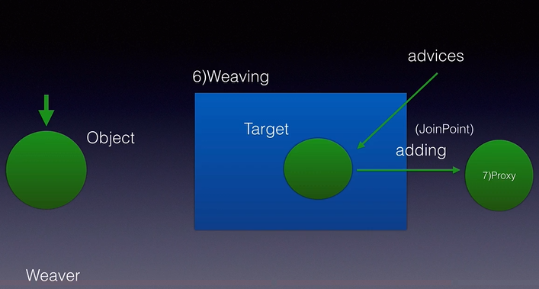

**PointCut Syntax 🡪** Using this we will qualify the business method.

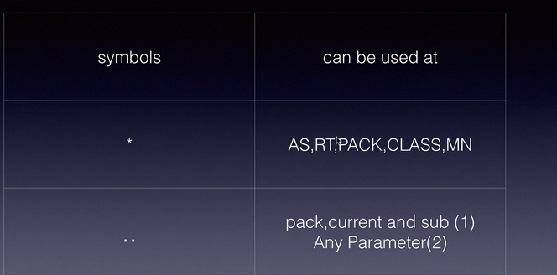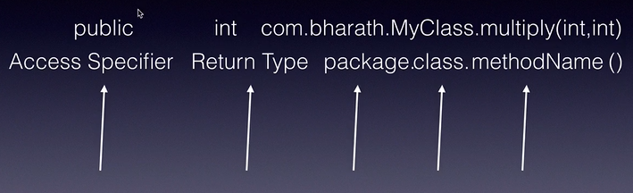

AS 🡪 Access Specifier

RT 🡪 Return Type

PACK 🡪 package

CLASS 🡪 class

MN 🡪 Method

Pack 🡪 “..” signifies current package and sub packages.  
if we define “..” at parameter then we define any parameter.

We have 2 wildcards symbols as **“*”** and “..” as explained above.

**Example:**

1. **public void *id() 🡪** In this it name of the **method name should end with “id”** and access specifier is public return type is void and does not have any parameter.
2. **Public int *e*(..) 🡪** In this **method name must contain “e”** access specifier should be public return type should int and **can contain any number and any type of parameter.**
3. **Public int get(..) 🡪** In this method name should exact match but any number and type of parameter.
4. **Public * * () 🡪** any method name and return type but without parameter.
5. **Public * com.app..* .get*() 🡪** In this it should start with get and end with anything, it can fall in any class since we have used “*” after package , package name com.app.. all the classes under com.app and its sub packages and return type could be any but no parameter and access specifier must be public.

* **AOP Frameworks**

3 major implementations of AOP are AspectJ, SpringAOP and JBoss AOP.

Internally Spring AOP supports AspectJ Annotation Driven and AspectJ XML Driven and Classic Spring Proxy-Based AOP which is open source.

We will learn AspectJ annotation Driven rest are outdated.

AspectJ Annotations:

1. @Aspect 🡪 Class level to mark the class as Aspect.
2. @Before, @After, @AfterReturning, @Around, @AfterThrowing 🡪 These are used at method level i.e. advise based on the condition we require.

The above methods are applied on Aspect classes i.e. the external classes which we will created.

**UseCase for implementation of AOP**

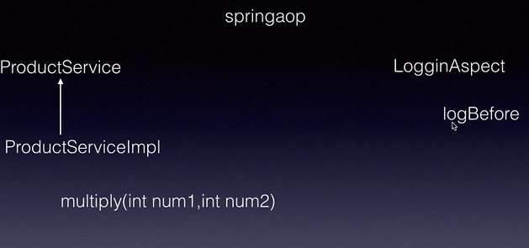

In above we will log some message on the console without touching the logic in Business class which multiply.

Step 1: 🡪 Create the Maven AOP Project.

In pom.xml apart from Spring core dependency we need to add the below dependency:

<dependency>

<groupId>org.springframework</groupId>

<artifactId>spring-aop</artifactId>

<version>${springframework.version}</version>

</dependency>

<dependency>

<groupId>org.aspectj</groupId>

<artifactId>aspectjrt</artifactId>

<version>1.6.11</version>

</dependency>

<dependency>

<groupId>org.aspectj</groupId>

<artifactId>aspectjweaver</artifactId>

<version>1.6.11</version>

</dependency>

Step 2: 🡪 Create POJOs i.e. Services and Interfaces.

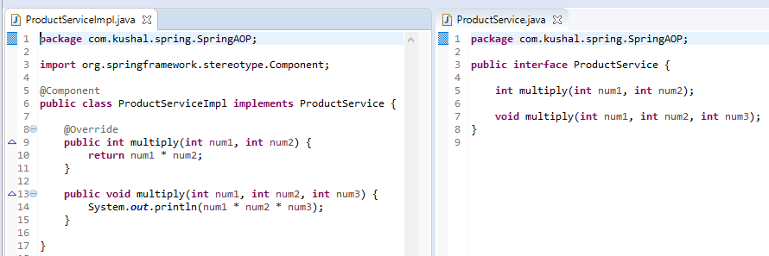

Step 3🡪 Create the Aspect class and mark it will @Aspect annotation.

PointCut expression shown below **execution(method details).**

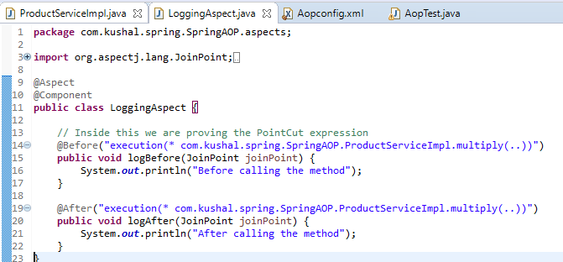

Step 4: Create the Spring configuration

In Spring we need to add 2 new XSD and namespace for AOP:

Namespace🡪 *xmlns:aop=*<http://www.springframework.org/schema/aop>

***XSD*** *🡪 http://www.springframework.org/schema/aop*

*http://www.springframework.org/schema/aop/spring-aop.xsd*

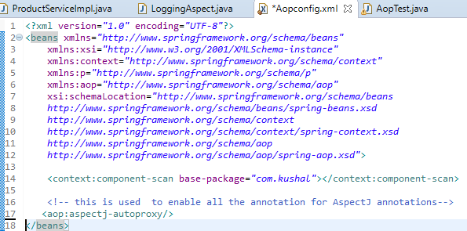

Step 5: Create and Run the test:

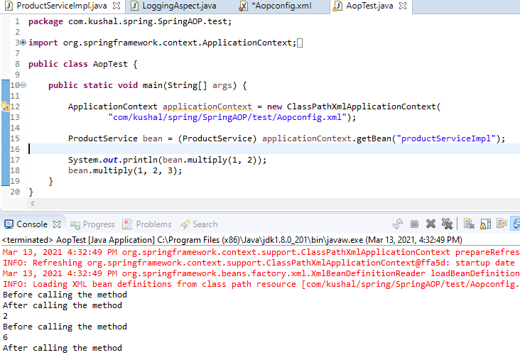

**Section 23: Java Configuration**

**Bring without using Spring Configuration file.**

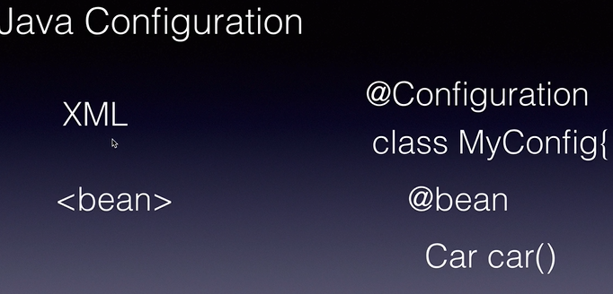

@Import annotation is used to import one config to another as we can define multiple configuration in our project.

**Use Case:**

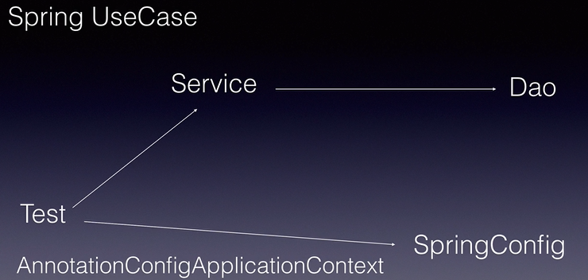

Step 1: Create the maven project with the following dependencies.

In this we will create the normal maven Quickstart project with Spring core dependency.

Step 2: We will create the Dao class and mark it as @Component annotation.

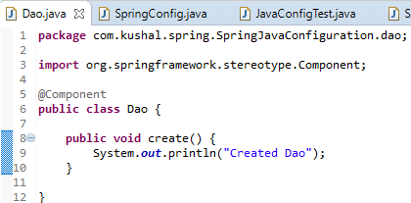

Step 3: We will create the Service class and inject the Dao object using @Autowired annotation and mark the Service class with @Component annotation.

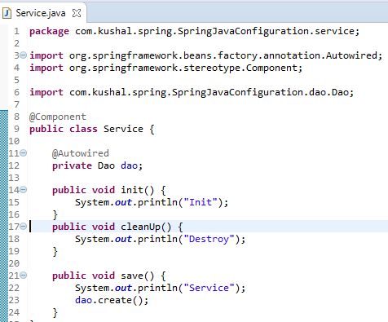

Step 4: Create java Configuration file and mark it with @Configuration and @Import is used to import other config into 1 config file. @Bean is used to configure bean.

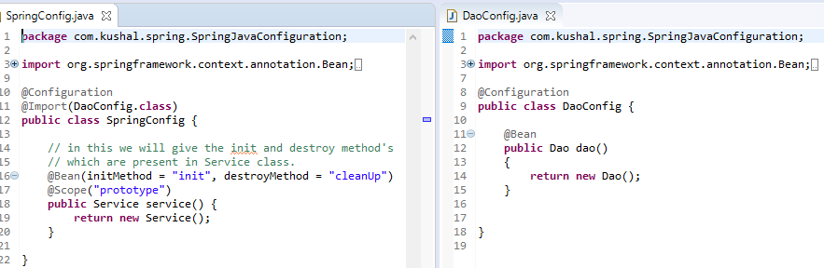

Step 5: Create the test class and see output:

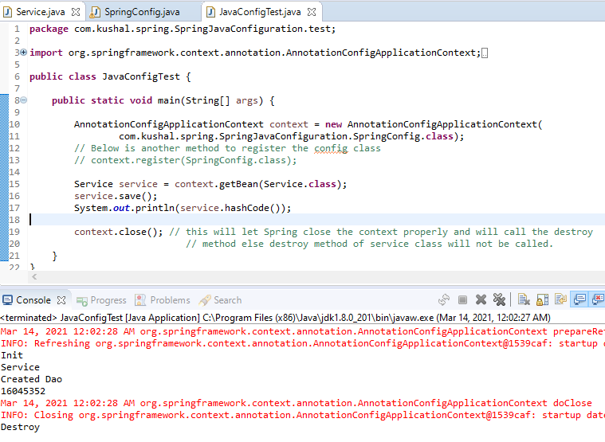

**Flow Chart:**

* Spring Container invokes the Spring Config java file then it creates 2 Bean first create the Dao bean then inject dao object in Service bean, as we have autowired it.
* After it invokes the Service bean and from it invokes dao class create method.

Notes :

1. When we use @Scope annotation and give the prototype then destroy method will not be called as object will be destroyed automatically by Spring.
2. When Scope of the bean is Singleton then same object is used for all the reference so object is not destroyed and when context is closed then Destroy method is called.

**Section 24: Spring Java Configuration in Web Application**

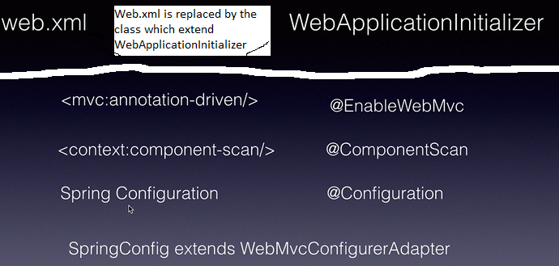**Use Case:**

As shown in Diagram SpringConfig class will extend WebMvcConfigureAdapter class and various xml tag will replacd by annotations.

**Below are steps we will perform:**

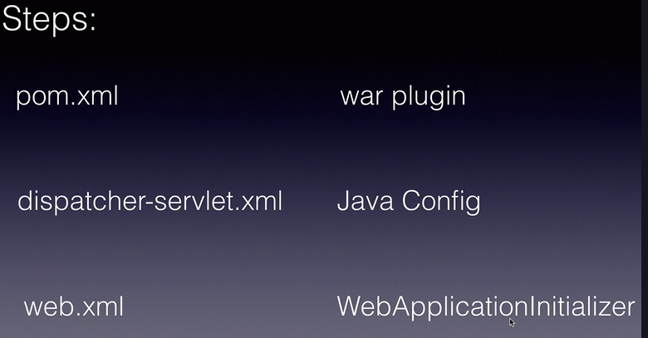

Step 1: Updating the pom.xml

1. Add the spring-webmvc depdendecy
2. Add the servlet-api depdendency
3. Now delete the plugin maven-compiler plugin and add the below Plugin:

<plugin>

<groupId>org.apache.maven.plugins</groupId>

<artifactId>maven-war-plugin</artifactId>

<version>2.4</version>

<configuration>

<warSourceDirectory>src/main/webapp</warSourceDirectory>

<warName>Spring_MVC_JavaConfiguration</warName>

<failOnMissingWebXml>false</failOnMissingWebXml>

</configuration>

</plugin>

In above is sued to tell that we are not web.xml as by default Spring will search for web.xml for every web application. <failOnMissingWebXml>false</failOnMissingWebXml> 🡪 This tag is used to tell that web.xml will not be used in our web application.

Step 2: 🡪 Create the Java Configuration, **i.e. replace dispatcher-servlet with JavaConfig**.

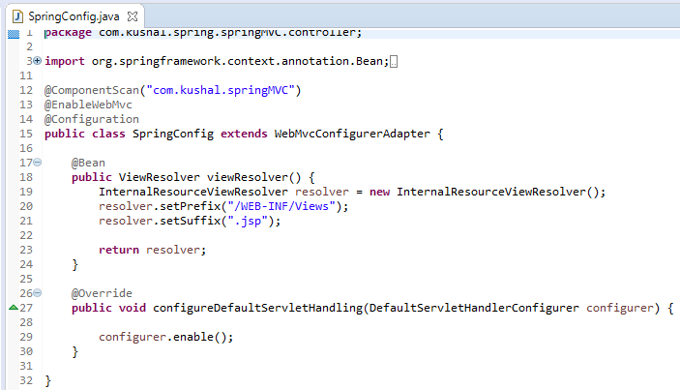

Step 2: Create the WeServletConfiguration which implements WebApplicationInitializer this is replacement of web.xml

Now delete the Spring Configuration file and web.xml.

